Different Brains & Complementary Skills
Building organisational value through the complementary skills of different brains in the office and diverse staff expertise

Table of Sections
1 Introduction 4
2 Different Brains & Complementary Skills – The Presentation 5
3 Evidence, reasoning and approaches 20
4 Solutions – How organisations can harness Different Brains in the Office 36
5 Appendices 68

Table of Contents
1 Introduction 4
2 Different Brains & Complementary Skills – The Presentation 5
2.1 Introduction 5
2.2 A set of people with a common trait 5
2.3 A disaster that could have been avoided 7
2.4 A spectrum for consideration 9
2.5 The people specialist perspective 10
2.6 The technical specialist perspective 10
2.7 Similar value across the spectrum 11
2.8 The physical foundations – Differing brain scans 12
2.9 The physical foundations – Visual processing brain scans 13
2.10 But we have a problem 14
2.11 Similar value across the spectrum 15
2.12 Solutions – Bringing complementary skills together 16
2.12.1 Complementary skills workshops 16
2.12.2 Genuine MDTs 17
2.13 Conclusions – Key points to take away 18
2.13.1 People have different valuable expertise 18
2.13.2 Communication gaps can be bridged with Complementary Skills 18
2.13.3 We need to move beyond our current employment approaches 19
3 Evidence, reasoning and approaches 20
3.1 Introduction 20
3.2 Sources and reasoning for specific information presented 20
3.2.1 Famous people with autism 20
3.2.2 Challenger space shuttle disaster 25
3.2.3 A spectrum – Empaths to autistics0 27
3.2.4 Brain scan slides – Empath and autistic brain scans 28
3.2.5 Brain scans – Visual thinker’s brain scan 28
3.2.6 But we have a problem – Current issues for diversity within organisations 29
3.2.7 Solutions – What we can do 30
3.3 About Complementary Skills Workshops 30
3.4 About Genuine MDTs 30
3.4.1 About Genuine MDTs, and why they’re different 30
3.4.2 Diversity in Genuine MDTs 30
3.4.3 Research to create new organisational value through Genuine MDTs 31
3.5 Diversity within organisations 31
3.5.1 Notes on potential challenges of diversity 32
3.5.2 Focusing on diversity the benefits of diversity rather than only avoiding discrimination 32
3.5.3 Creating an organisational culture that values diversity 32
3.5.4 Further resources on gaining organisational value from diversity 32
3.6 Prevalence of autism 33
3.6.1 In the general population 33
3.6.2 Autism in systems / technical roles 34
3.6.3 Exclusions 34
3.6.4 An example of a particular type of technical specialist – Considering cyber security specialists 34
3.7 Autistic strengths 35
4 Solutions – How organisations can harness Different Brains in the Office 36
4.1 The diversity value ecosystem 36
4.1.1 Introducing the diversity value ecosystem 36
4.1.2 The diversity value ecosystem – Parts to create the impact 36
4.1.3 The diversity value ecosystem – Problem / solution overview table 40
4.2 Training options – with minimal tailoring 45
4.2.1 Written communications skills for technical specialists 45
4.2.2 Individual communications coaching for technical specialists 45
4.2.3 Complementary skills workshops 45
4.2.4 Additional 46
4.3 Implementing Complementary Skills Workshops 46
4.4 Simplified Genuine MDTs as a quick-win 47
4.5 Project to design and implement the Genuine MDT approach 48
4.5.1 Preamble 48
4.5.2 Introduction – A project proposal to research Genuine MDTs 48
4.5.3 Objectives 48
4.5.4 Scope 48
4.5.5 Project phases 49
4.5.6 Project phase notes – Overview 51
4.5.7 Project phase notes – Phase A – Retrospective case studies 52
4.5.8 Project phase notes – Phase E – Evidence expansion research project 53
4.5.9 Resourcing 53
4.5.10 Sponsorship, funding and stakeholders 54
4.5.11 Some resources to get started – How to create Genuine MDTs 54
4.5.12 Intellectual humility and Genuine MDTs 56
4.6 Potential course – Persuasive Communications Skills for Technical Specialists 58
4.6.1 TLDR 58
4.6.2 Summary 58
4.6.3 The cohort 58
4.6.4 The organisational problem 59
4.6.5 Course components 60
4.6.6 Course principles 60
4.6.7 Steps to create the course 61
4.6.8 Context – Parts of the broader solution 62
4.7 Intellectual humility 63
4.7.1 Summary 63
4.7.2 About intellectual humility 63
4.7.3 Psychological safety 64
4.7.4 Intellectual humility in teams 64
4.7.5 The problem of autism and intellectual humility 64
4.7.6 Some extra notes on intellectual humility 66
4.7.7 Creating a course – intellectual humility for technical specialists 67
5 Appendices 68
5.1 Supplementary notes 68
5.1.1 History of Complementary Skills – sources of the idea 68
5.1.2 Differences in organisational cultures – technical and neurotypical 69
5.1.3 How to explain non-technical communications to technical people 69
5.2 Additional notes for the presentation edition 70
5.2.1 Slide 2 – A group of people with a common trait 70
5.2.2 Slide 3 – A disaster that could have been avoided 70
5.3 Sharing and licensing 70
5.4 References 71

Introduction
This document supports the presentation on the organisational criticality of neurodiverse groups, called Complementary Skills. It provides the expanded written form of, and supporting evidence for, the presentation, which was first created in May 2023.

The document is divided in to three main parts
- Section 2 – “Different Brains & Complementary Skills” on page 5, below.
  - The full text supporting the Complementary Skills presentation.
- Section 3 – “Evidence, reasoning and approaches” on page 20, below.
  - The evidence, reasoning and reference sources supporting the Complementary Skills presentation.
- Section 4 – “Solutions – How organisations can harness ” on page 36, below.
  - Potential solutions to the problems posed in the Complementary Solutions, some of the challenges expected in pursuing those solutions, and potential ways to address those challenges.
These are supported by the Appendices which provide, among other things, reference sources.

The latest edition of this document, along with the slide deck it is built around, is available by going to www.chrismalcher.com and selecting “Different brains in the office”.

Different Brains & Complementary Skills – The Presentation
This section provides an experimental draft written description of the Different Brains in the Office presentation.

Introduction
This is an article about a problem, a new perspective, and solutions.
It’s about complementary skills and different brains in the office. It’s about building organisational value from the diverse skills and expertise of all an organisation’s staff.
It describes the immense potential value of the different types of people that we have in our organisations, and how we can better utilise that value.

A set of people with a common trait
We’ll start with a little quiz.
Below is a list of people who share a single common trait.
They include Nobel laureates, Australian of the year, well-regarded writers, artists, musicians, successful entrepreneurs and others.
They’re people notable for achieving extraordinary things, extraordinary insights and extraordinary results.
A question for your consideration as you look at this list …
What do you think these people have in common?
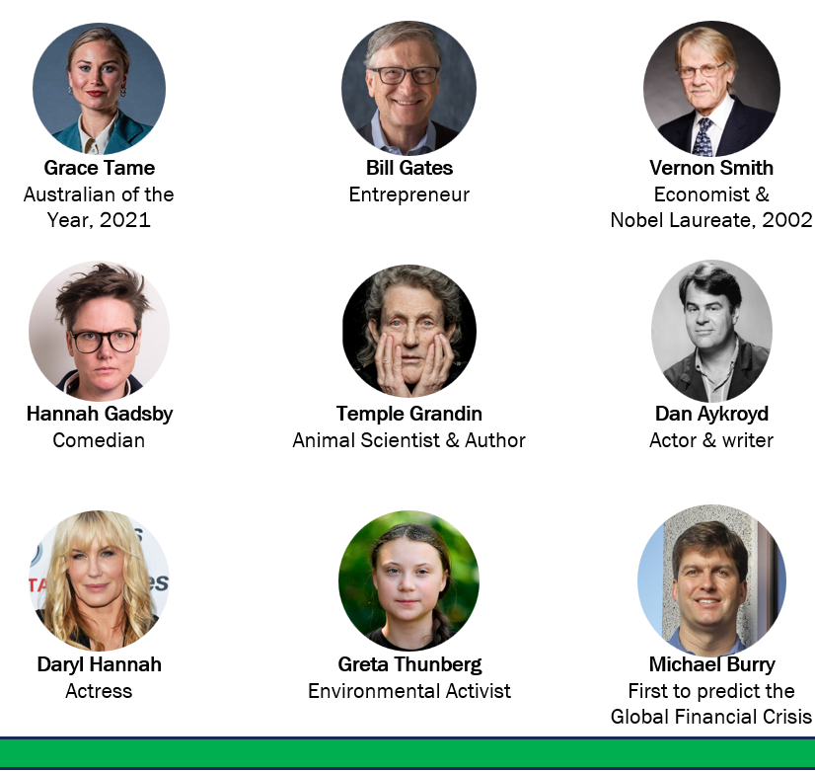
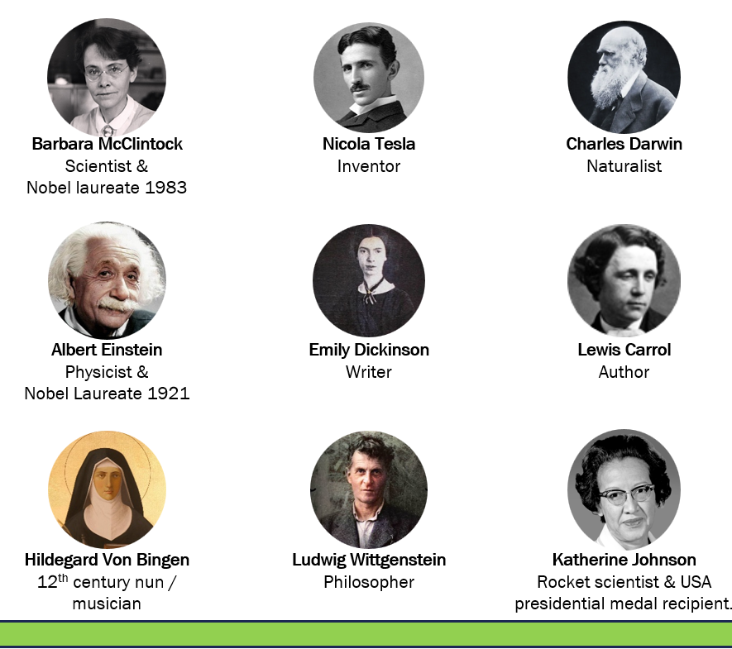

You may have noticed that they’re all very intelligent in their own ways.
You may also have noticed that they’re actually all a bit unusual. A bit weird in their own ways.
But they all share one common trait.

The answer to the question is that they all have autism. Specifically, all of them have Level 1 autism, previously otherwise known as high functioning autism or Asperger’s Syndrome.
The people in the first set have publicly stated their autism. For most of the people in the second set, researchers have analysed the material these people have left behind, and published their evidence showing high likelihood that they have autism.

This is not a group known for what they can’t do. This is not a group defined by a disability. Each and every one of them is included in this list because of the amazing things they’ve achieved.
I argue that they’ve all done extraordinary things, not in spite of their neurological condition, but because of it.
These people have brains that function a bit differently from most of the population. They’re very intelligent, and they think differently. This, in turn, has allowed them to develop abnormally high levels of expertise in very specific areas. That abnormally high expertise, combined with a bit of weird thinking practices, has enabled them to develop new insights which others have not previously grasped, and which many have benefited from.

Now I’d like to explore another impact from another form of expertise.

A disaster that could have been avoided
In January 1986 the Space Shuttle Challenger exploded shortly after take-off. As people around the world watched, the shuttle burst into flames and split apart, killing all seven on board.
The subsequent investigation to identify the causes of the tragedy found that it was caused by a leaking “O-ring” – a major piece of insulation on one of the shuttle’s fuel tanks.
The investigation also found that, in the days and weeks leading up to the tragedy, a group of engineers and rocket scientists had tried to warn of precisely this issue. The experts knew, and tried to tell senior decision-makers, that launching the shuttle in cold weather would make it susceptible to precisely the type of failure that occurred.
But there was a problem with communications, and their warnings were not heeded.
The result of this disconnected communication was that senior decision-makers didn’t appreciate the risk at hand. They authorised the launch, and the disaster is now a part of history.
Things could have been very different had the engineers been listened to. In this case, a tragedy could have been averted but for a barrier in communication.
Now let’s have a look at exactly what the engineers said.
The diagrams below were taken from faxes sent by engineers to senior decision-makers in the days immediately before the disaster.
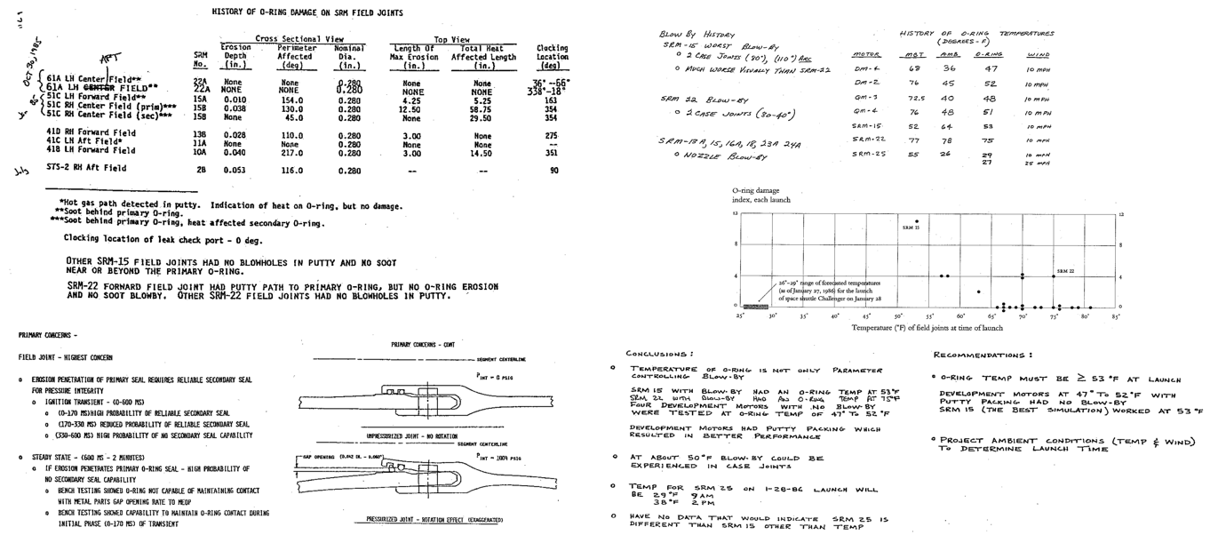
The problem was that the engineers tried to communicate their concerns like this;
In case you’d like to have a bit more of a look at the conclusions and recommendations;
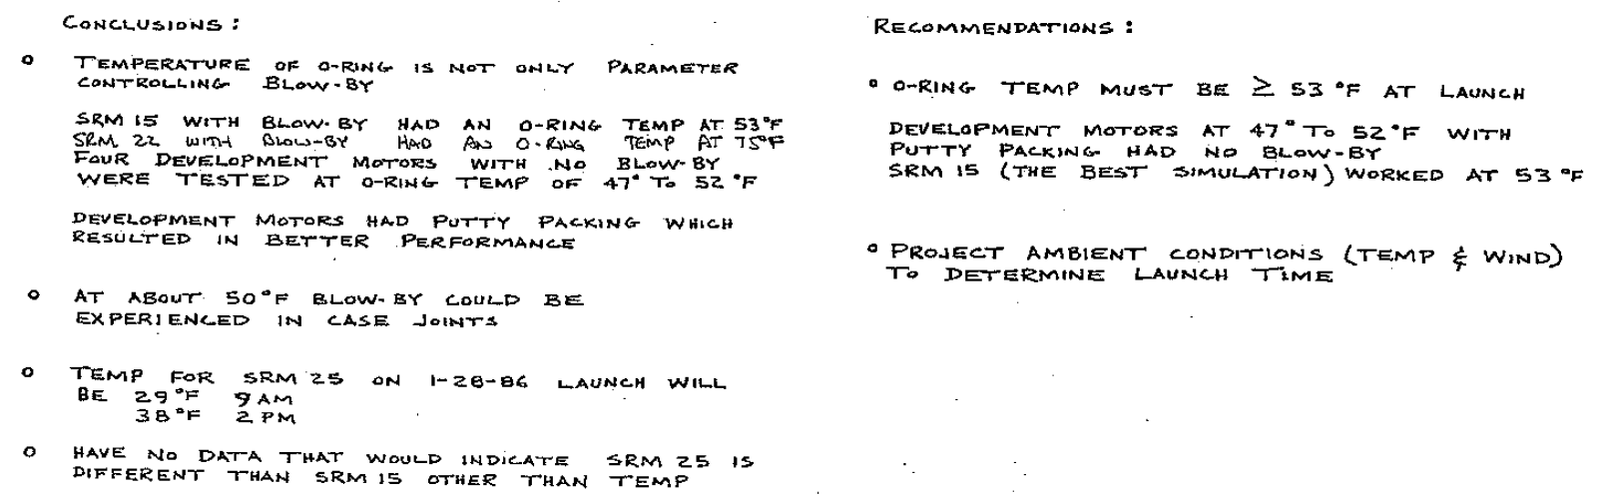
It would be quite reasonable to respond to these extracts with confusion.
While the information is technically accurate, it’s difficult to work out what the key points are, or what action should be taken.
The engineers had an important message to convey to senior decision-makers, and they tried to convey that message. Senior decision-makers, however, failed to properly grasp the mortal criticality of what the experts were saying.
They tried to communicate a very complex point in a complex manner that worked for people with their exceptional technical skills, such as other engineers.
But their communication didn’t convince their target audience.
The result of that communication gap was, in this case, a tragedy.
It’s almost as if the propensity someone has to understand and design new highly complex rules-based systems is inversely proportional to their ability to communicate that understanding to those without their ability.
And that is precisely the issue.
People with autism often have the intuitive ability and understanding of highly-complex systems that we need, but that abnormally high ability is at the expense of the ability to communicate their understanding with a neurotypical cohort.

Outside the field rocket science, in more “ordinary” organisations, teams of technically-minded people have this type of problem every day (although usually on less of a mortal scale).
In all organisations of significant size, we depend on people with high levels of expertise in highly specialised, highly complex and highly critical fields to define, design and create the things we need. This may be for financial models, legal designs, IT systems, engineering designs, scientific research, or even modelling legislative implementations. Any field focused on highly complex rules-based systems.
But: Those very tendencies and expertise we need in or organisations are exactly the tendencies and characteristics that make it most likely that the person’s communication style won’t work for most of the population.
This is not a fault. It’s a difference. And it’s a difference we fail to manage and utilise to our peril.

In terms of prevalence – people with autism make up roughly 5% to 10% of the general population. Significantly, there’s been some speculation that, in highly technical fields, autism prevalence could be over 50%. So the expert engineers and rocket scientists who were able to foresee the Challenger disaster (that others couldn’t understand) were most probably something of an autistic cohort.

Most organisations have similarly weird thinkers with abnormally high expertise that could bring great benefit to the organisation if ways could be found to fully harness that expertise.
Now I’d like to explore an idea that will help us to address that gap.

A spectrum for consideration
Imagine a spectrum describing types of people’s ability to intuitively understanding different things.
There are thousands of spectrums we could use to describe people. This is just one.
This spectrum we’re imagining is simplified to the point of being simplistic. We’re just focusing on one aspect to explore an idea.
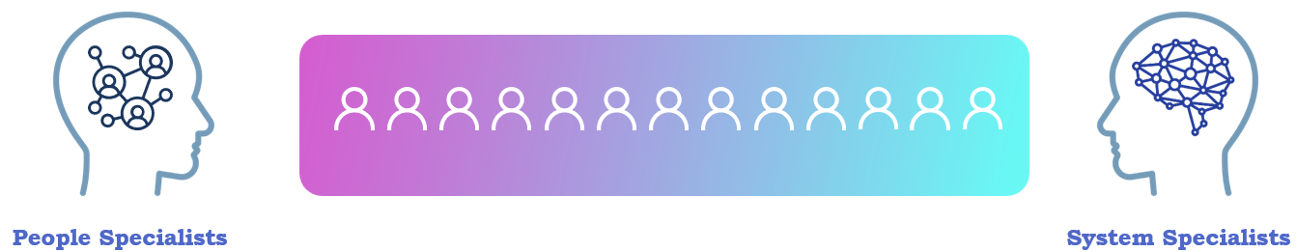
On the right of this particular spectrum we have the systems specialists (aka technical specialists). These are people who have very strong intuitive understanding of highly-complex rules-based systems and technologies. They may use their specialist expertise in areas such as finance, law, IT, engineering, or the physical sciences.
On the left we have the people specialists. These are people who have a very strong intuitive understanding of people, relationships, personalised needs and many forms of human communications.
In between we have the people with a bit of ability in both areas. They can understand people, and they can understand complex systems.
Everyone would be somewhere on this imaginary spectrum.

The people specialist perspective
Now, let’s look at a couple of aspects of that spectrum. We’ll start with the people specialists.
This triangle represents levels of people-focused skills at different points along the spectrum. People at different points in the spectrum would have different intuitive understanding of people, and different understandings of communications.
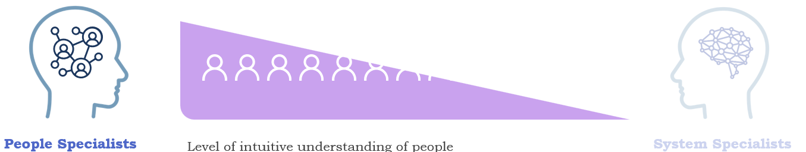

For the purposes of introducing the idea, I’m going to focus mainly on the extreme ends of this spectrum. Initially, it’s easier to get our heads around the concept with simple extremes.
On the far left-hand-side we could say we have the empaths. These are people with a very high level of intuitive understanding of other people, and consequently they’re frequently swamped by other people’s emotions. People at the left of this spectrum often intuitively understand other people’s motivations because they can sense what others are feeling.
And as you move to the centre, you have those who have a reasonable level of intuitive understanding of other people.
By the time we get to the far right-hand-side we’re looking at a group which, although experts in one area, really aren’t known for their intuitive understanding of neurotypical people.

The technical specialist perspective
But what about the opposite? What about the people on the right-hand side of this spectrum?
This next triangle represents the technical skills that people have at different points along the spectrum. At each point, different people have different levels of intuitive understanding of technical concepts, and different abilities to create new technical understandings and ideas.

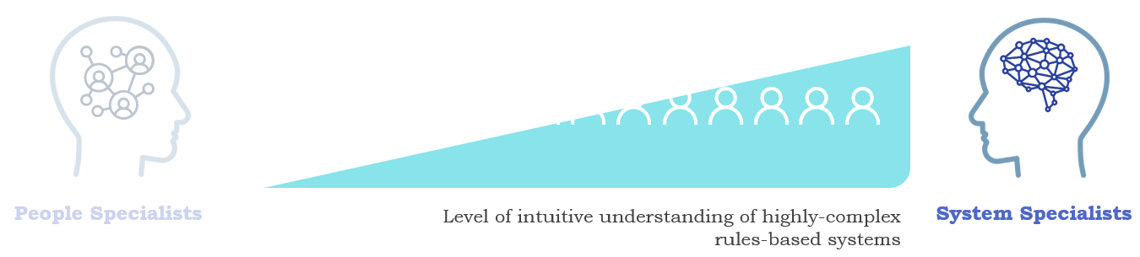
On the far right-hand-side of this spectrum we have people with an extremely strong ability to intuitively understand highly complex rules-based systems, but not so strong at intuitively understanding people. At the risk of a simplistic generalisation, on the right-hand-side we have people with autism. Within organisations that would mostly be Level 1 autism, which is the more mild form.
So, back to the diagram. As we move from the right-hand-side towards the middle, we have people who aren’t so strong in technical fields. Their skills span both technical-centric and people-centric fields.
By the time we get to the far left-hand side, we’re looking at people who really don’t have a very good understanding of technical concepts. They have expert abilities in other areas instead.

Similar value across the spectrum
You would have noticed from this that there’s more than one way to consider the skills organisations need. This is just one spectrum among the thousands that probably exist.

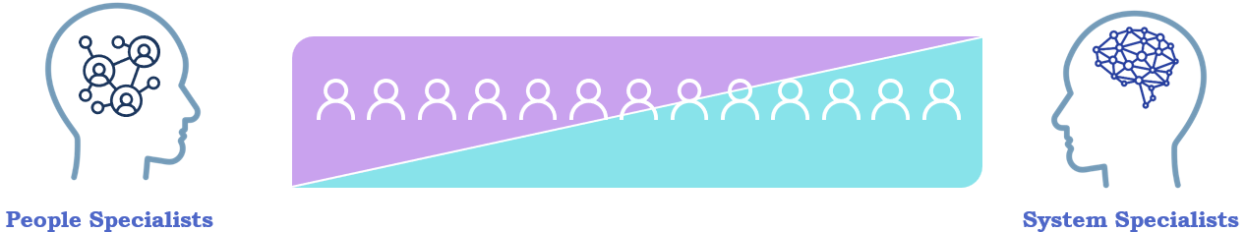

There’s more than one way to consider the skills that people have and, critically, being an expert in one area often means a person will probably be distinctly non-expert in another area. They’re effectively mutually exclusive areas expertise.
One of the key ideas from this is that there’s more than one type of skills that people have. The fact that people are not experts in one field doesn’t preclude the possibility that they’re experts in another field. In fact, expertise in some fields is effectually inversely proportional to expertise in a different field that requires a different way of understanding the world.
There are very different skills, very different areas, very different types of value.
The important thing is that everybody is 100% valuable. Wherever someone is on this particular imaginary spectrum, everybody’s mix of skill sets amounts to 100%, made up of different types of skill.
And we need all of them in organisation, using their very different expertise to create the many very different types of value that organisations need to be able to function well.
We need all of them.

The physical foundations – Differing brain scans
It’s important to note that these differences are more than just preferences. It's often about physically different brains.
Below are two sets of FMRI brain scans that help to illustrate this point.
Note that the images are deliberately too small to see the detail. At the moment, the main thing is to note that there’s a difference between the brains of people at the two different ends of the spectrum.
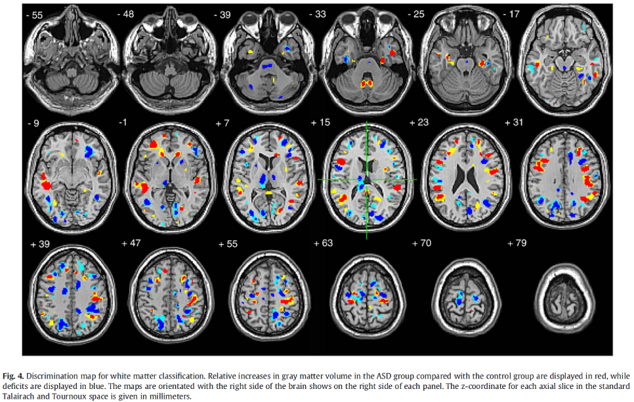
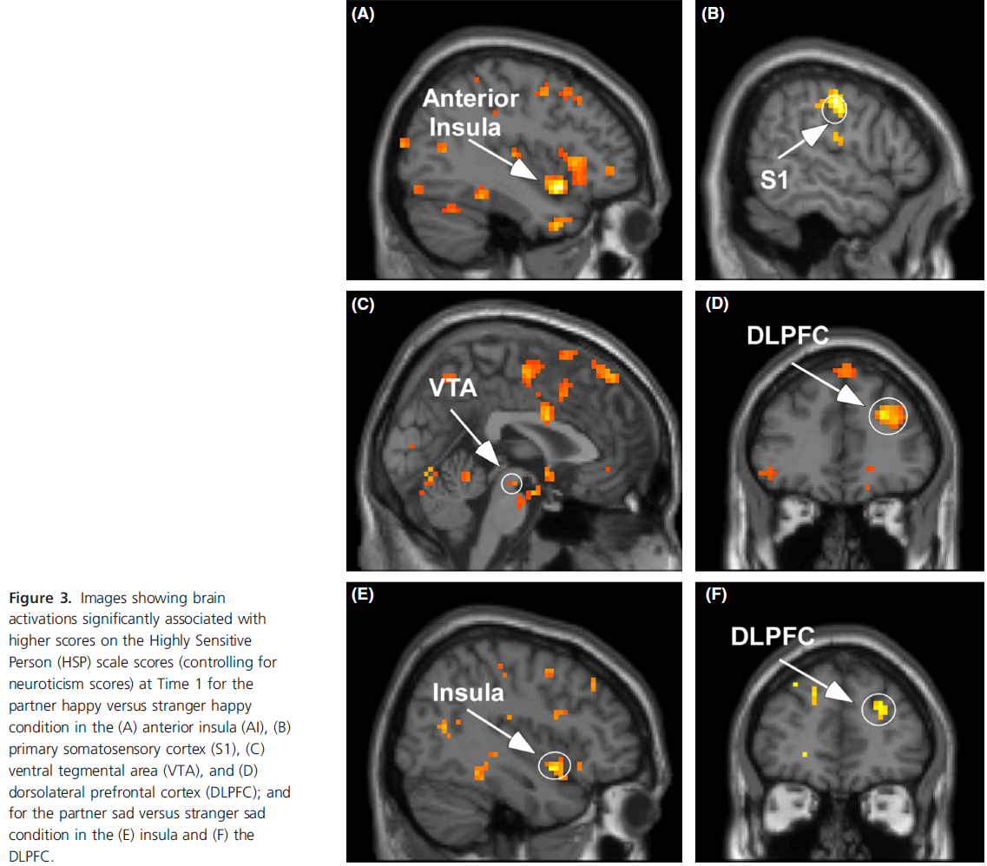

The left-hand set of images show the emotion-focused parts of the brains in empaths being more active in some situations than in the normal population in similar situations.
The right-hand set of images show the brains of autistic people with their brain activity that’s different from the normal population in similar situations.

While these images are deliberately too small to see the detail, even without seeing the detail these scans make clear is that there are measurable neurological differences between these cohorts.
The images are included to demonstrate that there are measurable neurological differences. If you’d like to delve in to the detail of these studies, references and DOI links are included in the evidence section, below.
In the meantime, we’ll go to a simpler example of another neurological difference to show how important this is.

The physical foundations – Visual processing brain scans
Next, I’d like to show you another set of fMRI brain scans that show how important different brains are.
This two images are from a study of people’s brain activity when performing visual processing tasks.
Control group | Temple Grandin
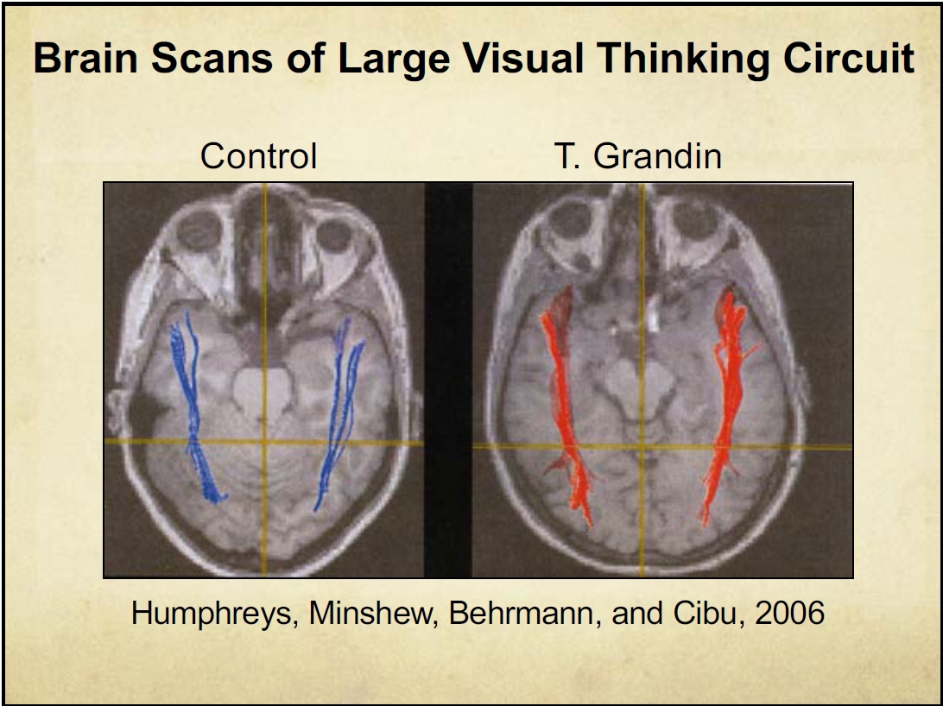
The scan on the left shows the brain activity of someone from the “normal” population performing a visual processing tasks.
The blue lines show that when this person is thinking carefully about what they’re seeing, there are neurological connections happening from the back of the brain (the visual cortex) to the front (which performs executive thinking functions). As you can see, there’s a fair bit of activity happening in this scan.
The brain scan on the right, however, is quite different.
This is a scan of Temple Grandin, a prominent writer well known for her abnormally high visual processing abilities.
In Temple’s scan, you can see from a quick examination that there are different things happening. There are more lines, indicating more connections between visual processing and executive function, and the colour of the lines indicates higher intensity of those connections.
Temple’s scan shows a clear physical difference between her brain and those of the “normal” population when performing exactly the same task.
As I mentioned, Temple is known for her very high visual processing abilities, and these scans appear to indicate that not only does she have more skills or practice in that space, but her brain is physically different when performing that activity.
She’s abnormally good at visual processing because her brain is functioning in a way that is abnormally good for visually processing tasks.

Within organisations, if they have someone who’s abnormally good at something important, that’s an important opportunity for the organisation. It’s in the organisation’s interests to find a way to utilise that expertise, even if that high-level skill is at the expense of some of the skills organisations normally seek – such as ability to communicate clearly with the general population.

But we have a problem
But we have a problem.
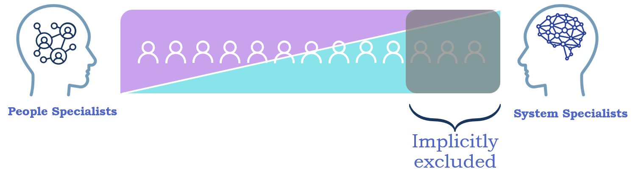
The way we engage, recruit and evaluate our staff seems to value only on certain parts of this spectrum.

In most organisations, value and recognition depend more on the ability to interact with neurotypical people than the ability to do highly complex work well. This works well for those who can understand neurotypical people, but doesn’t work so well for those with more of a systems or technical bent.
Our current ways of working effectively exclude the expert systems specialists we depend on.
Those systems specialists have abilities to understand things that others can’t.
They have skills that organisations need.
But they’re not good at communicating their insights with the general population.
As a direct consequence, organisation that use such one-dimensional filters for staff value will continue to struggle to utilise the skills of the expert systems specialists they have, continue to struggle to attract and reward the talent they need, and as a result continue to struggle to create new complex environments and tools that work well now and into the future.
The way organisations value and measure staff is creating direct problems for staff, and for organisational mission.

When it comes to recruitment and staff promotion, current staff management practices in many organisations effectively assume that neurotypical communications ability and idiosyncrasies are the best filter for valuing our staff.
As a result, those who can’t communicate well with neurotypicals are treated as less valuable, even if they have precisely the skills we need.
Standard interview and promotion practices demand the skills that systems specialists don’t have, and effectively ignore the critical skills they do have. This has the potential to negatively impact alignment between skills needed and who is hired.

A note on numbers of impacted staff.
In most organisations, more than half of people in technical roles are likely to have at least a mild form of autism.
Most moderately-sized organisations have an IT area, and in most of those, technical people generally make up at least half of the people in IT. So, if the IT part of an organisation has 400 people, then a minimum of 100 people in the autism would be likely to have autism. Minimum.
This is before we factor in all the other disciplines in which the skills that autism infers are likely to be needed – finance, law, IT, organisational design, science, engineering etc.
We’re not talking about just a few people here.
We’re talking about significant numbers of staff we’re making life unnecessarily hard for, and that normative practice is having a negative impact on organisations right now.

Similar value across the spectrum
It’s important to keep in mind that every at every point on this spectrum, everyone is valuable.
They're valuable for different things.
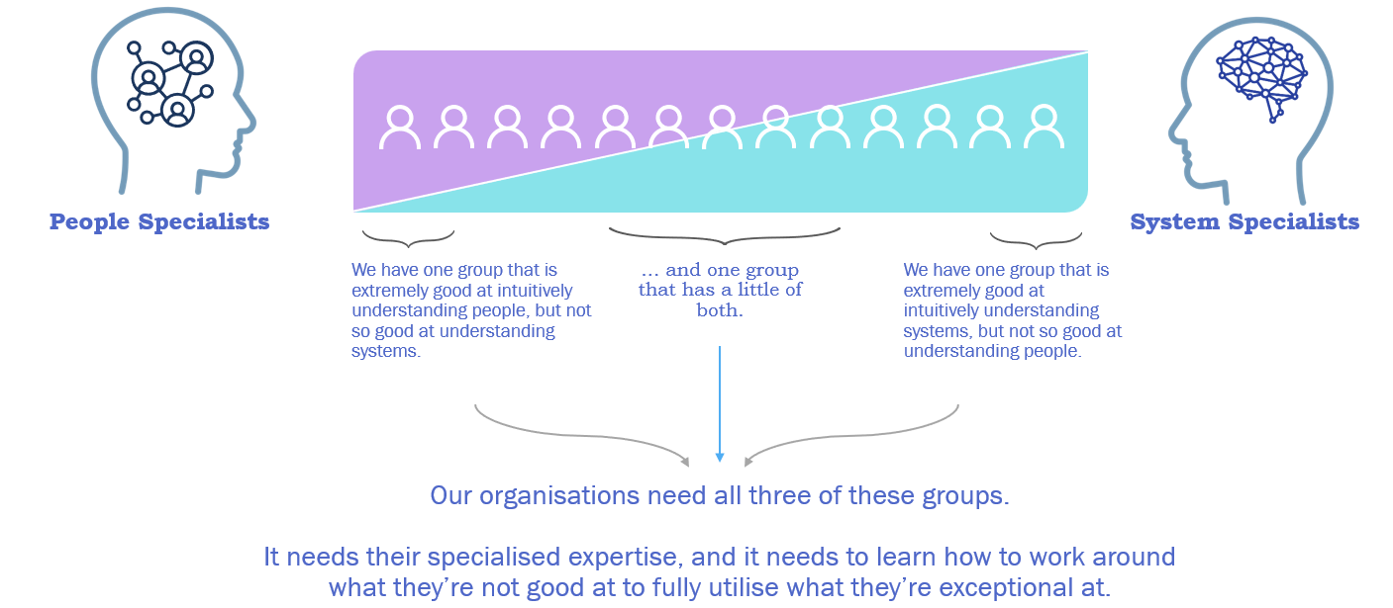

Along this spectrum we have three groups of people. Some have expertise in understanding people. Some have expertise in understanding systems of all types. Some have skills that span those areas, and can make productive use of ideas created by the people at one of the extremes.
They're valuable for their different skills, which can help the organisation in the many different ways it needs. If we just have a one dimensional way of valuing our staff and valuing our peers then we're not getting the full value out of our staff, we're not getting the full value out of our teams and we are exposing ourselves to risk to significant risk and problems as organisations.
But there are solutions. There are things we can do now, and things we can do in the longer term, that will help us value all our staff.

Solutions – Bringing complementary skills together
Now for the solution.
A way to make good use of technical thinkers.
As you saw in the Challenger example, different people have different insights. But sometimes the very skills that allow a certain group of people to create the insights are exactly the skills that mean they’re not very good at communicating those insights.
So what if we combine the best of both of those?
There are two ways to do this.

Complementary skills workshops
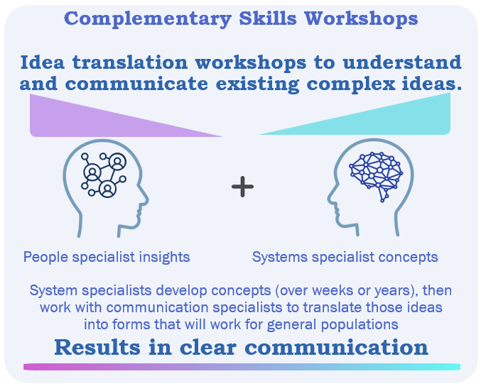
What if we work together to build insights, then use the expertise of people who think very differently to communicate those insights?
What if a technical specialist with an important complex concept could sit down with a communication expert and the communicator could extract the key messages the technical expert is trying to convey, and turn that into something that would work for a neurotypical cohort.
I’ve done this myself, and it’s worked extraordinarily well.
I’ve had complex concepts I’d been trying to explain, and no one was getting. Then someone suggested I work with a communicator on the message. We created this workshop approach and we came out with a way of explaining the concept that everybody understood quickly. The result was good for the organisation because it quickly lead to a pivot.

Genuine MDTs
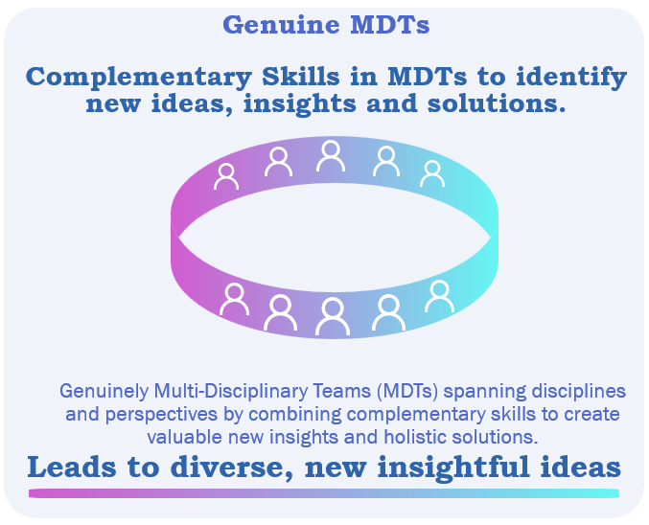
The other potential solution is genuine MDT.
It's an extension for complementary skills ID and that so MDTs – multi-disciplinary teams.
Theoretically, multi system routines bring together lots of different types of people to use their expertise on a particular task. In practice, especially in the public service RMD TS frequently.
Are quite similar disciplines with quite similar cultures.
So what this is focused on is.
Explicitly aiming to have very different people with different brains in the MDT and bring them together to create new value.
And I've done this.
And a few of us have done this.
On a few projects, for instance, when interviewing some customers on some recent LIFE event analysis work, the.
Working with service designers and customer experience analysts.
The service designers customer experience analysts, very people, people.
Would drive the interview and bring out from the interview with a customer or a member of staff a number of key insights, and I'd look at those key insights and I didn't see most of those things.
I simply didn't notice what they found. I'd bring out my insights from those same interviews, same conversations, exactly the same people.
And they were completely different.
We both had completely different sets of insights, but when you bring them together, you end up with a completely new set of ways of understanding the person and their experience and their environment and the implications of that that none of us could have even come close to build.
If we had been working on our own, so that was incredibly valuable because of the different perspectives.
And different ways and different brains that we bring to these and we've been able to show some very good value from that work.
So yeah, there are a couple of things we can do to bring those different brains together and get the value that we need for the organisation to both see opportunities to see risks and problems.
We are a bit of a grumpy bunch.
We do see problems first.
But then to find the solutions to those and to find them in places we haven't really previously known to look.

Conclusions – Key points to take away
People have different brains, different expertise, and different value to organisations. The greatest value comes when we recognise, harness and utilise that difference.
We need to shift our mindset and our ways of working to seek out high-level expertise in areas we may not yet fully comprehend, and to understand, appreciate, develop and utilise the expertise we already have.
So few key takeaways. So the first is different people have different valuable expertise.
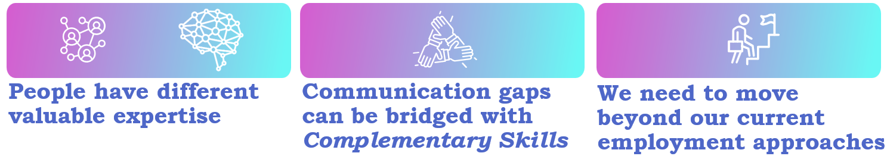

People have different valuable expertise
People have different brains, different expertise, and different value to organisations. The greatest value comes when we recognise, harness and utilise that difference.
We need to shift our mindset and our ways of working to seek out high-level expertise in areas we may not yet fully comprehend, and to understand, appreciate, develop and utilise the expertise we already have.
We don’t have to know everything ourselves.
Expertise is critical. In all fields, we need people who know a great deal about their fields. People who can advise, design and implement in ways that those without such knowledge can even grasp. We need people who don’t just know a bit about a field, but can create great new ways of doing things that take account of external impacts that non-experts could not grasp.
The people who have the expertise we need will, almost by definition, not be good at some other important things.
We can bridge that gap by working together. By cooperating closely with people who complement our own skills so that, together, we can take advantage of our very different types of expertise to create results of far greater value than we would ever have been able to create on our own.

Communication gaps can be bridged with Complementary Skills
There are effective methods we can use to harness the value of different brains in the office.
Implementing Complementary Skills workshops and Genuine MDTs can help to bridge the gaps between technical experts and non-technical people.
Complementary Skills workshops can be used to translate existing complex technical concepts to a form that would suit a general audience.
Well-run Genuine MDTs can harness the value of different brains stimulating each other to create new insights, new approaches and new solutions to new and existing problems and opportunities.

We need to move beyond our current employment approaches
Our current employment and hierarchy practices do not cater well to the career progression of technical people.
Under the current system, if technical people seek to achieve an employment level in line with their true value to the organisation, they are required to become experts in communicating well with neurotypicals, and managing staff. This is not only very difficult for a person with autism, but also takes them away from their highest value activities – utilising their area of specialist expertise.
If we’re to attract and retain the expertise we need, we need to develop employment approaches and pathways that recognise and reward technical expertise.

Evidence, reasoning and approaches

Introduction
This section outlines the evidence behind the claims made in the presentation, as well as the reasoning and thinking approaches used to extrapolate from, and extend beyond, the foundation provided by current empirical evidence.
While this article is fully in line with a peer-reviewed evidence base, it does extrapolate beyond that evidence in places.
In this section I’ve endeavoured to outline the relevant evidence, the extrapolations, and the thinking behind my assertions above.

Sources and reasoning for specific information presented
This sub-section contains the primary references. Supporting information is in the next section.

Famous people with autism
Presentation slide 2.

Famous people with autism – The confirmed cases

People who‘ve publicly confirmed they have autism
Reference sources for my claim that these people have publicly confirmed their autism.

- Grace Tame – Australian of the Year, 2021
    - In her book “The Ninth Life of a Diamond Miner: A memoir”, Grace Tame outlines her experience growing up with autism, and the impact it had on her traumatic experiences (Tame, 2022).
- Temple Grandin – Animal scientist & author
    - Grandin has written and spoken extensively on her autism, and the impact it has on her life. Her book “The Autistic Brain: Helping Different Kinds of Minds Succeed” (Grandin, 2014) continues that theme.
- Hannah Gadsby – Comedian
    - “Ever since I can remember, my thoughts have been plagued by a sense that I was a little out of whack, as if belonging was beyond me. … I wish more than anything that I had known about my ASD when I was a kid, just so I could have learned how to look after my own distress, instead of assuming my pain was normal and deserved.” (Gadsby, 2022).
- Vernon Smith – Economist & Nobel Laureate, 2002
    - “What happens when children with autism grow up? It may sound paradoxical, but some with the mildest form, Asperger Syndrome, may turn out to be stars. … `I don't have any trouble thinking outside the box,’ he said. `I don't feel any social pressure to do things the way other people are doing them, professionally. And so I have been more open to different ways of looking at a lot of the problems in economics.’ " (Herera, 2005).
- Daryl Hannah – Actress
    - “Hannah, who was diagnosed with autism as a child and suffered from “debilitating shyness” as a result of the disorder, says the best thing in her life now is growing comfortable in her own skin.” (Dodd, 2013).
- Greta Thunberg – Environmental activist
    - “When haters go after your looks and differences, it means they have nowhere left to go. And then you know you’re winning! I have Aspergers and that means I’m sometimes a bit different from the norm. And - given the right circumstances- being different is a superpower.” (Rourke, 2019). From a Post on Twitter (“X”), quoted in the article. The original X post is available at: www.x.com/GretaThunberg/status/1167916177927991296.
- Dan Aykroyd – Actor & writer
    - “I have Asperger's - one of my symptoms included being obsessed with ghosts” (Ewing, 2013).
- Michael Burry – Investor.
    - First predict the 2007 Global Financial Crisis (GFC).
    - Lewis first realised he had autism (Asperger’s syndrome, at the time) when his son was diagnosed with the condition. (Lewis, 2010, Chapter eight)
- Bill Gates – Entrepreneur
    - “If I were growing up today I probably would be diagnosed on the autism spectrum.” (Gates, 2025)

Additional publicly confirmed cases (not included in the presentation)
- Fern Brady – Comedian
    - “[Brady’s book] Strong Female Character … documents the turmoil of growing up with undiagnosed autism, during which she excelled academically but struggled with sensory overload … It took until she was 34 to get an autism diagnosis.” (Sturges, 2024).
- Susan Boyle – Singer
    - “[Boyle] has revealed that she was misdiagnosed after complications at birth and has actually had Asperger's, a high-functioning form of autism.” (Deveney, 2013).

Famous people with autism – The speculated cases
A caveat
The speculated examples of people with autism are just that, speculated. External evidence and indications have been used to determine whether behaviours and inclinations recorded about the people in question are common among autistic people. From this, an informal (and non-professional) assessment was made of whether, on balance of probabilities, these people had (or have) autism.
It is important to note that labelling someone autistic is not giving them a negative label. I’ve included them because they’re people who’ve achieved great things and, I assert, their autism has been one of the positive contributors to their ability to achieve those great things. It could be argued, quite forcefully, that autism is positively associated with scientific breakthroughs (James, 2003, Griswold, 2024).
Caveat: The examples provided in this section are speculated cases included as examples only. They do not presume to be formal diagnoses. The entire idea that it is possible to remotely diagnose people with neurological / neurobiological conditions is disputed by many psychiatrists (e.g.: Weinstein, 2023), and is against diagnostic methods recommended in, among other sources, DSM-5 (American Psychiatric Association, 2022). That said, I’ve tried to include only cases which have a high likelihood of being on the autism spectrum.

The speculated cases
- Barbara McClintock – Scientist & Nobel laureate, 1983.
  - Barbara McClintock (1902-1992) “made great breakthroughs in the study of chromosomes and how they change during the reproduction process. McClintock has long been thought of as autistic in some way. She had an extreme fixation on her work and was able to focus for long periods of time. She was also very particular about what she would and would not wear. She was notably reclusive and one who went to great lengths to avoid any attention of limelight”. (Applied Behavior Analysis Programs Guide, 2025).
  - (Cage, 2020)
  - (Elder, 2006)
- Emily Dickinson – Writer
  - Dickenson is identified as an author demonstrating symptoms of autism in Julie Brown’s book “Writer’s on the Spectrum” (Brown, 2010).
- Nikola Tesla – Inventor
  - Some of Nicola Tesla’s behaviour that indicated likely autism included
    - A carefully regimented daily schedule with work from 09:00. to 18:00, and dinner at the same restaurant at precisely 20:10., to be served only by the headwaiter.
    - Physical tics such as repeatedly curling his toes 100 times each night.
    - His eidetic memory that allowed him to instantly memorise books and possess perfect recall, allowing him to learn 8 languages easily.
    - He demonstrated an early ability to perform complex integral calculus computations in his head.
    - He became obsessed with electricity at an early age.
    - (Applied Behavior Analysis Programs Guide, 2025).
- Albert Einstein – Physicist & Nobel Laureate (1921)
  - (Baron-Cohen et al, 2009, James, 2003, Orzel, 2024).
- Lewis Carrol – Writer
  - (Calabrese et al, 2017).
- Hildegard Von Bingen – 12th Century nun and musician
  - Hildegard Von Bingen demonstrated extraordinary talents during her life, alongside difficulties in basic activities such as writing and speaking (Ranft, 2014). But her music remains an inspiration eight centuries later, and continues to inspire (Allan, 2025).
  - Hildegard Von Bingen demonstrated difficultly in all but visual forms of communication, including speech and writing, but also showed a “single-mindedness and willingness to abandon outside interests [which are] frequently [a] formula for success, particularly in … music’ ” (Ranft, 2014).
  - Ranft also notes that monastic life may have been helpful for someone with autism at the time. She highlights “how similar the routines of monastic life and ASD treatment programs are. Each is highly structured, individualised with low teacher/student ratios, demands hierarchical relationships and intense engagement, offers systematic teaching and encourages family/community involvement.” (Ranft, 2014).
- Ludwig Wittgenstein – Philosopher
  - (Fitzgerald, 2000).
- Charles Darwin – Naturalist
  - “Newton, Einstein, Darwin, Cavendish, Dalton, Dirac, the Curies—the personalities that emerge from the biographies of such individuals stand out in several respects, including being remarkably similar to one another and being classifiable by a telltale collection of traits: shy, taciturn, socially awkward, intensely focused, late talking, habitual in routine, echolalic, etc. (James, 2003). Indeed, there is not one social butterfly to be found anywhere upon this list. Autism was not a known concept when these individuals lived, but if they were among the population today, their spectrum-like characteristics would be difficult to ignore.” (Griswold, 2024)
- Katherine Johnson – Mathematician and rocket scientist
  - Katherine Johnson was a “human computer” in the NASA space programme in the 1950’s and 1960’s. In 2015 she received the USA “Presidential Medal of Freedom” (Ford, 2015)
  - In her early years, in common with many kids with autism, Katherine Johnson was obsessed with counting (“I counted everything”, NASA, 2015). She went on to demonstrate exceptional abilities in mathematics, and earnt a PhD in the field in 1937, an exceptional achievement for anyone at that time, especially for a black woman. In 1958, while working for NASA, she had such a strong reputation for reliable manual orbital trajectory calculations that the first American to orbit the Earth, John Glenn “personally requested that Johnson verify the flight trajectory that had been worked out by one of the new electronic computers.” (Grady, 2020).
  - While these traits and events do not conclusively prove that Katherine Johnson had autism, it is highly likely. To those with deep knowledge of the indicators and abnormal strengths of autism, it’s difficult to imagine someone with Katherine Johnson’s life path to have not had the condition.

People not yet included – externally speculated
- Terry Pratchett – Writer
  - (Fitzgerald, 2023).
- Henry Cavendish – Scientist
  - (Lidbetter, 2009).
- Isaac Newton – Scientist
  - “Newton's boyhood enthusiasm for constructing mechanical models developed into a passion for making scientific instruments, especially optical instruments, and he did so supremely well. … in fact Newton appears to be the earliest known example of a person with any form of autism.” (James, 2003).
- Adam Smith
  - (Ortmann, 2021).
- Irène Joliot-Curie
  - Joliot-Curie “had great difficulties in greeting and dealing with strangers. She was described as ‘rather awkward in her movements’, by nature very reserved; she had difficulty in making friends. She never acquired the art of casual conversation and grew up insensitive to the attitude of others. In argument she was incapable of the least deceit or artifice or of making the smallest concession.” (James, 2003)
- Margaret Hamilton – Mathematician and rocket scientist
  - Margaret Hamilton was a mathematician and software engineer who, among other things, lead the 1960’s guidance software project for the Apollo rocket systems. She has received multiple awards for her technical work, including honorary doctorates, and the USA’s Presidential Medal of Freedom in 2016 (White House Archives, 2016).
  - While she has never been formally diagnosed with autism (as far as the public record indicates), and there is no explicit or direct evidence that she has autism, she has demonstrated a number of traits where are likely to be associated with people with autism. These include; expert proficiency in multiple highly technical fields (mathematics, software engineering, weather system modelling and astro-navigation), intense attention to detail, a focus on complex technical fields, an ability to foresee risks.
  - One example of Margaret Hamilton’s (possibly) autistic trait of foreseeing risks that others denied may be useful. During the Apollo moon landing programme in the 1960’s, Margaret apparently foresaw significant critical system overload issues that others (presumably neurotypicals) denied (Whittell, 2019 and Corbyn, 2019). These overloads were low likelihood but very high impact – they could have caused a mission abort. Among many common traits among people with autism is a natural tendency to consider the problems of a situation, including low-likelihood risks. Margaret Hamilton’s use of this inclination in the design of Apollo control computers and moon landing practice sessions directly contributed to flight crew being ready, and not mistaking computer overload messages during live landing preparations as being a life-threating system failure that would have otherwise aborted the mission.
- Marie Curie – Nobel Prize in physics (1903) and Nobel Prize in Chemistry (1911)
  - Of her new husband, Pierre Curie, “[Marie] herself observed that `his dreamer’s spirit would not submit to the ordering of intellectual effort imposed by a school” — and added the prescient observation that he belonged to an unusual “intellectual category, which nonetheless includes more representatives than one would believe”. — in effect, a diagnosis of autism and an observation that it was a relatively widespread phenomenon.” (Waltz, 2013) [??? Find a better quote (about Marie, not her husband). Start with Waltz’s book).

Challenger space shuttle disaster
Presentation slide 3.
Diagrams and report extracts from engineers submission, prior to Space Shuttle Challenger explosion (Tuftle, 1997).
- The Decision to Launch the Space Shuttle Challenger
“On January 28, 1986, the space shuttle Challenger exploded and seven astronauts died because two rubber 0-rings leaked. These rings had lost their resiliency because the shuttle was launched on a very cold day. Ambient temperatures were in the low 30s [degrees Fahrenheit] and the 0-rings themselves were much colder, less than 20°F.
… the exact cause of the accident was intensely debated during the evening before the launch.
In management schools, the accident serves as a case study for reflections about groupthink, technical decision-making in the face of political pressure, and bureaucratic failures to communicate. For the authors of engineering textbooks and for the physicist Richard Feynman, the Challenger accident simply confirmed what they already knew; awful consequences result when heroic engineers are ignored by villainous administrators. In the field of statistics, the accident is evoked. to demonstrate the importance of risk assessment, data graphs, fitting models to data, and requiring students of engineering to attend classes in statistics. For sociologists, the accident is a symptom of structural history, bureaucracy, and conformity to organisational norms.”
Tuftle, 1997.

Many studies have examined the Challenger disaster that have informed the example;
- Robinson et al (2002) points to an issue with gaps in data provided to engineers from previous incidents.
- Rossow (2012) highlighted communication challenges as the main issue.
- The USA’s Committee on Science and Technology (1986) pointed the finger at a shift of NASA from a research focus to a business focus, and a pressure for volume (number of launches per year) overriding a focus on safety in NASA’s space programmes.
- Roger Boisjoly, one of the NASA engineers who tried to stop the Challenger launch, has written extensively on the ethical factors that contributed to the Challenger disaster. He has run workshops exploring the conversations and decision-making leading up to the launch (Boisjoly, 1987). Others have written on his role in the relationships between organisational and individual responsibility (Boisjoly et al, 1989),

Another disaster with important similarities – Space Shuttle Columbia, 2003
It’s notable that a similar issue may have occurred with the Space Shuttle Columbia Disaster in 2003. In this case, information about complex technical issues was provided through an extensive (possibly excessive) slide deck of complex technical detail (Thomas, 2019) which seemed to emphasise what was done over the results of what that work.
A 2003 summary report into the Columbia disaster (Smith, 2003) identified “organisational barriers that prevented effective communication of critical safety information and stifled professional differences of opinion”.
Reviews of the disaster highlighted that efforts to summarise complex technical information into succinct slide decks can inadvertently cause critical risk. The primary investigation board highlighted this issue as;
“As information gets passed up an organisation hierarchy, from people who do analysis to mid-level managers to high-level leadership, key explanations and supporting information is filtered out. In this context, it is easy to understand how a senior manager might read this PowerPoint slide and not realise that it addresses a life-threatening situation.
“At many points during its investigation, the Board was surprised to receive similar presentation slides from NASA officials in place of technical reports. The Board views the endemic use of PowerPoint briefing slides instead of technical papers as an illustration of the problematic methods of technical communication at NASA.”
(Columbia Accident Investigation Board, 2003).
The result of all those factors was that those with the expertise in the field, and the best understanding of the problem, did not effectively communicate their concerns. This resulted in continuation of the mission, and a disaster for all concerned.

A note on the link between autism and engineering – a historical perspective
The examples above deliberately focused on engineers (and the rocket science engineering speciality) as an indication of autistic value and challenges. As early as the 1960’s the understanding that engineers were, generally, “different” had extended to academic studies of personality. The traits described then would now be seen as indicators of autism.
For example;
- Izard (1960) conducted personality tests on 81 engineers and found significant differences in their personalities from the “normal” population, including that “things and processes appeal to engineers more than do people”.
- Beall and Bordin (1964), also looking at the personality traits of engineers, noted that they tend to concentrate on “material products and practical outcomes”, and that through their specialisation in engineering “satisfy [their] mainly impersonal curiosities”.
- Elton and Rose (1967) found “significant personality differences” among engineering students who stay in the field and those who move to other disciplines during their studies. Those who stayed demonstrated traits we would now identify as likely indicators of autism.
- This understanding of a distinction continued into the 1980’s. For example, Stegar (1985) identified that highly capable engineers didn’t necessarily make good managers, mainly because of differences in emotional awareness and skills. Although Stegar goes on to put this down to training differences, subsequent research into the differences in interpersonal skills of people with autism, and the resulting diagnostic criteria (American Psychiatric Society, 2015) indicates that there’s a great deal more to this difference than just training.
- More recently, Williamson et al (2013) has highlighted that engineers generally have somewhat different personality traits from non-engineers, including scoring higher on “tough-mindedness and intrinsic motivation, but lower on conscientiousness and emotional stability.

A spectrum – Empaths to autistics0
Presentation slides 4 to 7.

Focusing on the extremes in the office – empaths
I’ve based my description here of what’s happening on the extreme right on what’s outlined in the DSM-5 – the standard manual for diagnosing neurological conditions. For better or for worse, “Empath” is not listed as a condition in the DSM-5, but that’s whole other issue (although many related conditions are).

Focusing on the extremes in the office – Level 1 autism
There’s quite solid evidence of a diagnosis rate for autism of at least 3% (??? Ref), with some studies pointing to around 7%.
Some specialists in the field also speculate that prevalence of autism in highly technical fields could easily be over 50%. I’ve spoken (off the record) to two psychiatrists and more than half-a-dozen registered psychologists about this, and so far the only disagreement on that point has been that the real prevalence is “way over that”. Of course, these assertions are entirely off the record. To date, there is no solid evidence available to substantiate that assertion.
Highly technical fields here refer to those such as electrical engineering, medical research, IT, cyber security, financial forensic analysis, and even some aspects of organisational planning.

Everyone is somewhere on this spectrum

Caveats for the spectrum
- This spectrum exists to convey a point.
- It is simple to the point of being simplistic.
- That means that in the interest of making the initial point easy to convey and understand, to show people that this is a point worth hearing, the continuum has been simplified to the point of being just plain wrong.
- In order to convey the initial point, many complicating factors have been removed from the concept.
- The concept here is (roughly) in alignment with the DSM-5 description with autism.
- But that means it fails to account for at least 51% of the population. It fails to account for the level of emotional awareness and emotional impact experienced by women with autism.
- It fails to account for the fact that “Empath” is not a diagnosable condition, even when being constantly swamped by other people’s emotions is inevitably overwhelming and often leads to crippling anxiety.

Brain scan slides – Empath and autistic brain scans
Presentation slide 8.
- Brain scans of empaths (“Highly Sensitive Persons”) were taken from this paper (Acevedo, 2014).
- Brain scan showing differences in people with autism (Ecker et al, 2010).

Evidence
- It’s been found that direct neurological modifications in mice can reduce (or increase) more significant symptoms of symptoms, further pointing to the condition’s physical nature (Jang et al, 2025).

Brain scans – Visual thinker’s brain scan
Presentation slide 9.
- Temple Grandin’s brain scan images (Grandin, 2022).
- The brain scans that Temple Grandin shared are most likely to have been created for one, or both, of these two studies (Thomas et al, 2011) or (Bermann et al, 2006).
  - NOTE: Temple Grandin quotes her source as “Humphreys, Minshew, Bermann and Cebu, 2006” (with no link or DOI), but no paper precisely matching that reference has yet been found. The papers referenced above are the most likely related studies.
For reference purposes, another brain scan image from Temple’s presentation is available here: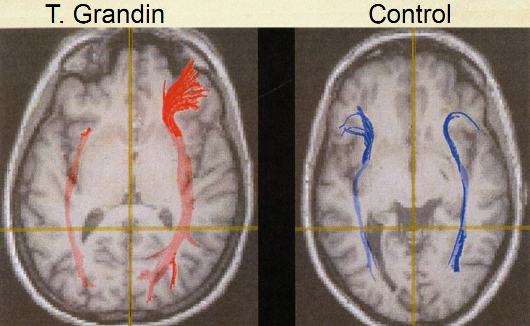

But we have a problem – Current issues for diversity within organisations
Presentation slide 10

Issue
Linear views of hierarchy and career progression create an artificial plateau in technical specialists’ careers, and make it difficult to move roles. Existing organisational requirements for “span of control” and similar assumptions of leadership responsibilities at higher levels mean that it’s difficult to develop expert staff above basic management level.
Existing organisational requirements for “span of control” and similar assumptions of leadership responsibilities at higher levels mean that it’s difficult to develop expert staff above basic management level.
Under “span of control” concepts, staff above basic management level are required to shift their focus away from there are of specialist expertise to something they are unlikely to become skilled at.
The result is a loss of value for the organisation, stress for the individual, and lack of career options for the technical specialist cohort as a whole.
As a result, technical specialist staff can either plateau at basic management level, go to senior management and fail to perform, or quit the organisation and become a contractor or consultant.
It is also possible that this distortion may contribute to the high proportion of contractors in many organisational IT areas. With many organisational guidelines preventing paying technical experts their true value, these skills can only be obtained by hiring those who have avoided the restrictions of the organisation’s career progression paths.

Solution
Update employment frameworks to address the challenges of technical specialists, including creating realistic career paths for non-managerial experts, and reviewing recruitment practices
Allow promotion based on technical skill without mandating that more senior staff should also manage staff. Recognise that there is more than one way to demonstrate expertise, and people leadership isn’t the only measure of value of whether someone should be promoted.
Ideally, technical roles would continue to at least the equivalent of senior manager level, while still allowing staff to focus on their skill area.
Examine recruitment practices to remove barriers for those not exceedingly skilled in interpersonal communications, but who have expertise in the role they’re applying for.

Comment:
Such a change could give technical people APS career paths without destroying their value as technical experts.
CM, 10/3/2023: In 2022 the APS Hierarchy review recommended a “technical” stream that pays more than stock-standard APS levels. It was immediately rejected by the APSC.
See Complementary Skills.

Solutions – What we can do
Presentation slide 12.
Information on the two main solution approaches outlined are available in:
- Section 3.3 – “About Complementary Skills Workshops” on page 30, below.
- Section 3.4 – “About Genuine MDTs” on page 30, below.

About Complementary Skills Workshops
In Complementary Skills workshops, a technical specialist with an important concept to be shared sits down for a number of hours with an expert communicator to translate that concept to something that would work for a neurotypical audience.
Within that workshop, the expert communicator identifies and refines the key messages that need to be communicated, then builds that messaging in a way that would be understandable and persuasive for a neurotypical cohort.
The aim is to go from autistic insights to persuasive actionable neurotypical messaging.
The aim is to translate from one brain type’s way of thinking about important issues to another’s.

Further information on Complementary Skills Workshops is available in Section 4.3 – “Implementing Complementary Skills Workshops” on page 46, below.

About Genuine MDTs
This section provides further information on Genuine MDTs and their value. It builds on the introduction in Section 2.12 – “Solutions – Bringing complementary skills together” on page 16, above, and is supported by Section 3.5 (“Diversity within organisations” on page 31, below).
The Genuine MDT concept remains under development. One valuable way to accelerate this development is outlined in Section 4.5 – “Project to design and implement the Genuine MDT approach” on page 48, below.

About Genuine MDTs, and why they’re different
Multi-disciplinary teams (MDTs) are, ideally, groups of people from different fields of expertise who come together to achieve a particular goal.
In most organisations, multi-disciplinary teams do genuinely involve multiple disciplines, but these disciplines tend to be quite closely related and, similarly, the people brought in tend to think of the world in quite similar ways, or at least from similar perspectives.
The term “Genuine MDTs” is used to delineate a type of MDT that’s more explicitly focused on ensuring it incorporates in to its core people with very different perspectives on life and work, from very different disciplines, and frequently very different brains.

Diversity in Genuine MDTs
Diversity is a critical component of Genuine MDTs. It’s the explicit focus on accessing and utilising different forms of diversity that makes Genuine MDTs different, and valuable.
How diverse teams operate, and how they share information, also has an impact on the effectiveness of the MDT. The advantages of a diversity of information sources (through a diversity of types of brains) require that information be “shared and then integrated during group discussions” (Phillips et al, 2004). Without that integration, information remains just information, and doesn’t become knowledge in the heads of team members, markedly reducing its value.
The nature, and value, of diversity within organisations is more directly covered in Section 3.5 – “Diversity within organisations” on page 31, below.

Research to create new organisational value through Genuine MDTs
The evidence base on ways to access the organisational value of diversity is currently not particularly robust.
Similarly, solid evidence-based advice on how to create and implement Genuine MDTs within organisations is also lacking.
Addressing that gap will require significant effort by one or multiple organisations.
To support organisational efforts to address that gap, a draft outline for a project proposal has been put together.
See Section 4.5 – “Project to design and implement the Genuine MDT approach” on page 48, below.

Diversity within organisations
“If you want to build teams or organisations capable of innovating, you need diversity. Diversity enhances creativity. It encourages the search for novel information and perspectives, leading to better decision-making and problem-solving. Diversity can improve the bottom line of companies and lead to unfettered discoveries and breakthrough innovations. Even simply being exposed to diversity can change the way you think.” (Phillips, 2014).

A paper by Specht & Crowston (2022) explored, and demonstrated, the value of diversity in scientific research teams (although with some caveats);
“We think we have shown that, with some provisos and a degree of management, … diversity of participants in a working group does lead to diverse practices and outcomes.”
“Group diversity is not just a goal in itself, but is rather a support for building an interdisciplinary collaboration, the success of which has benefits for output (in moderation).”
“Research has become so complex that individual scientists cannot achieve meaningful results without collaborating—the so-called collaboration imperative”
“Our findings reinforce the importance and apparent benefits of diversity of various types in research groups. They also indicate the need to pay attention to the interdisciplinarity of the collaboration itself and being more deliberate about the combination of new knowledge, working to ensure that the groups bring together their diverse perspectives. The negative impacts on satisfaction and effectiveness due to diversity … suggest a need to help participants with the knowledge integration process to make it more enjoyable and ensure fidelity within the group.” (Specht & Crowston, 2022).

While diversity can contribute to reducing unnecessary risk (gender diverse boards reduce risk of high-risk investment – e.g.: Muller-Kahle et al, 2011), it isn’t guaranteed to improve results in all cases (e.g.: diversity among teachers doesn’t appear to improve student results –e.g.: Chapple et al, 2014).

Notes on potential challenges of diversity
It should be noted that unfortunately to this point, the research into diversity of gender and ethnicity has failed to find a conclusive benefit (e.g.: Noland et al, 2016 and Green et al, 2021). In some cases, diversity may even reduce thorough examination of risks (Miller et al, 1998) if the diversity of views is not well managed.
It’s important to note, however, that much of the research into the organisational value of various forms of diversity does not appear to thoroughly factor in the role that intellectual humility plays in gaining value from different views and perspectives. People low in intellectual humility are unlikely to carefully consider views that do not align with their own (Snow, 2022 and Leary et al, 2017). In groups of people with low intellectual humility, disagreements are more likely to result in conflict (Leary et al, 2017).

Focusing on diversity the benefits of diversity rather than only avoiding discrimination

More than just avoiding the problems of discrimination
Diversity is all too often treated as something to manage the problems of. Diversity is often seen as something to accommodate to avoid the problems of (overt) discrimination. It’s not yet common enough that organisations actively seek and harness diversity for the benefits it can bring the organisation, its staff and its stakeholders.
- “Organisations recognise the importance of workforce diversity but tend to focus on its negative dimensions— preventing discrimination and exclusion—rather than explicitly championing its positive performance benefits. These benefits do not arise automatically but require systemic, integrated interventions.”(van Knippenberg et al, 2020).

Creating an organisational culture that values diversity
An organisational culture in which diversity in general, and neurodiversity in particular, is critical for any initiative that aims to harness diversity.
Many writers and researchers have explored how to accommodate and include diverse staff.
Less has been written about how to actively gain value from diverse staff.

Further resources on gaining organisational value from diversity
Diversity is a critical foundational attribute of the organisational value of different brains in the office.
Understanding and harnessing that value is covered in these sections;
Introducing the ideas
- Section 3.3 – “About Complementary Skills Workshops” on page 30, above.
- Section 3.4 – “About Genuine MDTs” on page 30, above.
Practical solutions
- Section 4.3 – “Implementing Complementary Skills Workshops” on page 46, below.
- Section 4.4 – “Simplified Genuine MDTs as a quick-win” on page 47, below.
Paths for research and robust solutions
- Section 4.5 – “Project to design and implement the Genuine MDT approach” on page 48, below.

Prevalence of autism
In terms of prevalence – people with autism make up roughly 5% to 10% of the general population. Significantly, there’s been some speculation that, in highly technical fields, autism prevalence could be over 50%. It’s important to note, however, that no robust studies are known that back up this higher rate – the assertion is based on clinician experience an inference rather than robust double-blind studies or similar. Significantly, however, very little if anything has been found that firmly contradicts such an assertion. So the expert engineers and rocket scientists who were able to foresee the Challenger disaster (that others couldn’t understand) were most probably something of an autistic cohort.

In the general population
- The article is written with the assumption that, among the general population, around 5% to 10% are likely to be autistic. This is a rough approximation of prevalence based on diagnosis rates from various studies of 2.8% (in the USA (Maenner, 2023)), and 7.2% worldwide (Thomas et al, 2015). One earlier study showed a diagnosis rate of 3.4% based on DSM-IV, which uses a tighter definition of autism (Fombonne, 2003). In common with many health fields (and even law enforcement fields), true rates are likely to be significantly higher than diagnosis levels would indicate on their own. Therefore, a higher range of 5% to 10% has been used in this paper for actual prevalence of the condition.

What’s included in “autism”
- For the purposes of this article, the term “autism” is being used broadly, encompassing grey space of definitions. Consequently, the changes in diagnostic criteria introduced in DSM-V (American Psychiatric Society, 2013) which, in practice, move some previously autistic traits to Social (Pragmatic) Communication Disorder (SPCD), are included under “autism” for the purposes of this article. This inclusion has been done partly for simplification, and partly due to some debate in the psychological about the overlaps between autism and SPCD (e.g.: Amoretti et al, 2021 and Norbury, 2013).

A few notes on empirical evidence on prevalence of autism
- One ADHD study identified a prevalence of 7.2% in the general population (Thomas et al, 2015). There’s quite a high comorbidity (co-existence) between ADHD and Autism. More than half of the people with one will also have the other.
- In one study, amongst those who met criteria for autism diagnosis, 25% were undiagnosed, and 31% were assessed as Level 1 autism (i.e.: some support required) (Wiggins et al, 2019). As a result, there’s a bit of a disconnect between diagnosis rates and actual rates.
- In the UK, there was “an overall 787% increase in recorded incidence of autism diagnosis over 20 years”, from 1998 to 2018. “Current findings … indicate the overall trend is actually one of the increasing application of diagnosis over time” (Russell et al, 2022). In other words, the increase in reported figures isn’t due to a change in the number of autistic people. It’s due to only a change in diagnosis of people who are autistic whether or not they have a diagnosis.

Autism in systems / technical roles
- Technical parts of a large organisation are likely to be made up of at least 25% autistic staff.
  - The suggested figure of 25% of people being (mildly) autistic in technical parts of an organisation is based on an assertion that, in highly technical roles (e.g.: Engineering, science, IT, medical research etc), more than 50% of people are likely to be on the autism spectrum. If we then assume that in parts of organisations focused on technical functions (e.g.: IT areas of organisations), at least half of those staff are likely to be in highly technical roles. From this, at least 25% of people in highly technical fields are likely to be on the autism spectrum.
  - The figure above of at least 50% autism in highly technical roles is a rough estimation based on personal experience of multiple clinical psychologists and psychiatrists in Australia. It is not based on any peer-reviewed studies (none could be found on this specific point), but it is consistent with observations, demonstrated behaviours, and the career choices of autistic professionals who visit the qualified mental health professionals contacted.
- One study indicates that 22% of people in STEM careers have autistic traits.
  - “As predicted, sex and occupation differences were observed: on average, males (m = 21.55, SD = 8.82) scored higher than females (m = 18.95; SD = 8.52), and individuals working in a STEM career (m = 21.92, SD = 8.92) scored higher than individuals non-STEM careers (m = 18.92, SD = 8.48).” (Ruzich et al, 2015).
  - This study also pointed to 19% of the general population having autistic traits. That could well be debatable. It is highly likely that professions well suited to autistic interests and mindsets have significantly higher rates of autistic experts than other professions. At this stage, however, there is little evidence to support or dispute this point.

Exclusions
In focusing on professionals with Level 1 autism, we explicitly exclude a number of cohorts with autism, in particular people with autism with intellectual disabilities.

An example of a particular type of technical specialist – Considering cyber security specialists
It takes a certain type of mind to be able to see the linkages between settings on a network server, and build the realisation that a certain obscure combination of those settings, under certain unusual circumstances, could theoretically enable someone to access our critical data.
If we don’t have people who can identify those security exposure points, it creates a major risk for the organisation. Failing to realise and address similar obscure cyber security gaps has caused many organisations to expose their customer data, and be completely shut down for an extend period of time.
I would hazard a guess that the group most likely to have the mindset required to realise those linkages and exposure points is those on the autism spectrum.
And the traits on the autism spectrum that make someone good at identifying security exposure points, and therefore mitigating risks for the organisation, are the same traits that make communication difficult.
An intense and sustained interest in, and a deep knowledge of, a detailed technical area. A focus on technical linkages.

Autistic strengths
While this entire piece is focused on understanding and harnessing the strengths of level 1 autism, in actual fact the empirical evidence on this front isn’t as strong as would be ideal.
In lieu of a complete empirical answer on this question, these pieces of research may be of use.
- Autism appears to infer certain genetic advantages for survivability (Polimanti et al, 2017).
- The detail-focused cognitive style of many people with autism appears to pre-dispose affected people to focused talents. Autism appears to be a processing bias rather than a deficit as such (Happé et al, 2009).
- Autistic children with strong interests related to detail focus in some areas were found to “have talents outstripping older children” (Happé et al, 2009)
- Autistic people have been found to have “cognitive advantages such as superior creativity, focus, and memory; increased efficiency and personal qualities such as honesty and dedication; and the ability to offer a unique autism-specific perspective.” (Cope et al, 2022).
- People with autism view the world through hyper-systemising (that is, view most things as complex systems), and as a result often demonstrate expertise in recognising patterns and connections in “systemisable domains” (Baron-Cohen et al, 2009).

When considering the intrinsic strengths or otherwise of any group different from our own, it’s worth analysing the metrics we’re using. If we measure other people by our own restrictive ideas of value, they’re very likely to come up short – as we would if measured by their ideas of value.
If measured exclusively in terms of ability to function in neurotypical corporate political environments, then autistic people will inevitably show inadequacies. But if measured in terms of ability to deeply understand the complex systems that many organisations depend on and/or exist in, then very different results will be achieved – resulting in very different ideas of who is “valuable” within an organisation.

Solutions – How organisations can harness Different Brains in the Office

The diversity value ecosystem

Introducing the diversity value ecosystem
[dhdhdh – Need some text here that says “this is the whole thing, with all its parts – you can choose which parts you implement. But do it in the knowledge that you’re just picking out part of the full solution”]

The issues
Large organisations employ many people who are respected in their particular fields, including organisational design, law, IT, data science, finance, and others. However, in many cases the traits that enable these experts to develop their specialist knowledge are the same traits that may make it difficult for them to persuasively communicate their insights to senior decision-makers. That is, there’s an inverse relationship between their ability to understand complex rules-based systems and their ability to communicate their resulting insights with neurotypical cohorts.
As a result, decision-makers may not adequately understand the more complex organisational opportunities, issues and risks, with potential adverse impacts on the organisation’s outcomes.

The solutions
There are many parts to the solution to this issue. The table on the next page breaks the issue down into seven problems, and recommends potential solutions.
Importantly, due to current gaps in the relevant evidence bases, some solutions will, at this stage, require significant investment to build an evidence base, and to design practical practices in line with that evidence base.

The diversity value ecosystem – Parts to create the impact

The diversity value ecosystem overview diagram
The set diagram below visualises the four domains involved in building an organisation that understands, values, and appropriately utilises its neurodiverse staff. Each domain is explored in more detail in the table following.
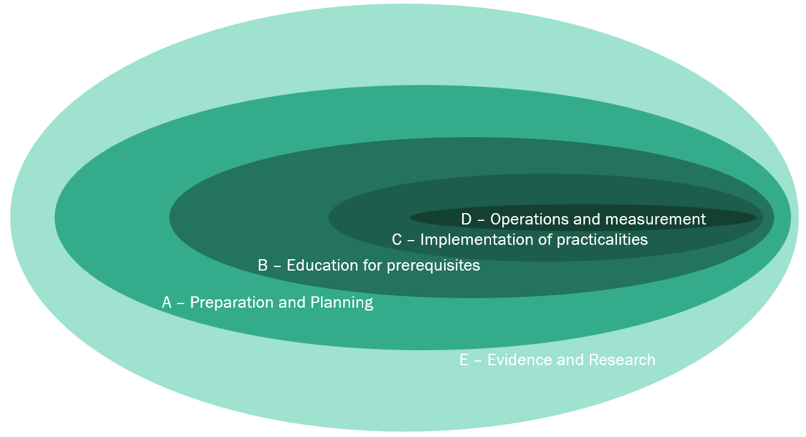

Descriptions of the four ecosystem domains
The four domains of the diversity value ecosystem are made up of many parts
A – Preparation and Planning
This covers working out how to approach the initiative, build senior stakeholder support for the whole direction, and plan how the organisation should adapt.
- Planning
  - Describe, articulate, share and refine the goals and objectives of the initiative
  - Describe metrics to be applied, and how they’ll be applied.
  - Establish a project to implement the changes.
- Enhancing the organisational environment
  - Improving the organisation’s understanding and culture to value and constructively utilise diversity.
  - This focuses on whole-of-organisation changes, such as organisational culture and direction. It does not (yet) include training for individuals.
  - It includes “side projects” to re-examine and enhance how the organisation understands its staff with (potentially) different brains, and how staff levels and hierarchical structures could/should be refined to better value and access specialist expertise.
B – Education for prerequisites
This is education to get things ready. The foundational education to get people into the headspace that will be needed to make this work.
- Education and training for managers
  - Education and training for managers of diverse workforces, with a focus on understanding, valuing and positively utilising the value of neurodiverse staff.
- Education and training for technical specialists
  - Education and training tailored to a neurodiverse cohort working in neurotypical environments.
C – Implementation of practicalities
This covers running the project, the practical training (how to do the thing), monitoring, and adjustment/improvement.
- Training and implementation for enhanced team practices
  - Includes education and training for Complementary Skills workshops and Genuine MDTs.
- Implementing the new practices
  - Includes activation of the new structures, approaches and practices
- Building the organisational culture
  - Embed and re-iterate an organisational culture that values diversity and actively seeks it to achieve organisational aims.
D – Operations and Measurement
Embedding the new approaches and practices in to the organisation’s ways of working.
- Measurement and monitoring
  - Monitor progress as change is implemented
  - Monitor the effectiveness of implemented results
  - Share results to support open dialogue and top-to-bottom continuous improvement
- Continuous improvement
  - Review results
  - Identify potential areas of improvement
  - Prioritise changes to the practice
  - Design improvement changes (i.e.: back to “A – Preparation” for the individual improvements)
  - Implement improvements (i.e.: back to “B – Education” and “C – Implementation” for the individual improvements)
E – Evidence and Research
This is both internal practical research (shorter term) and working with academic institutions to encourage deeper research over a longer time period.
- Internal research
  - Practical experimentation in to how best to run diverse teams.
  - Practical experimentation in to how to bridge the communications gaps between neurotypical and neurodiverse team members.
- Research in partnership with academic institutions
  - Research to address current gaps in the empirical evidence base relating to different brains in the office
  - Research to address current gaps in the empirical evidence base on how to productively harness divers neurotypes within organisations.
  - Research to address current gaps in the empirical evidence base on persuasive communications skills for technical specialists.

The diversity value ecosystem – Problem / solution overview table
The table below provides a summary of the various solutions available to implement the Complementary Skills approach.
There are many items in this list to break down the problems and solutions into separate components that are somewhat less daunting to design and implement.

Category & Ref | Heading | Issue / Problem | Issue Description | Solution | Solution Description | Link | Creation effort scale | Comments
A - Preparation and Planning, Ref 01 | Design of the overarching approach (filling in the details) | We don’t yet have an implementable way to do this | There are many parts to building an organisation that properly understand, values and productively utilises expert staff with different brains. We don't currently have a holistic way to do this. | Establish a dedicated pre-project initiative to design how we’ll approach this challenge, and its solutions | There is a need fully built out way to implement, and achieve the value from, the Diversity Value Ecosystem model. |  |  | [This document provides the framing for this activity, not the detail. The detail still needs to be worked out]
A - Preparation and Planning, Ref 02 | Knowledge of the cohort | Gaps in organisational understanding of the technical specialist cohort | Lack of organisational awareness of the alternative approaches needed to deal with the fact that, although “technical specialists” have very valuable areas of expertise, communications is not generally among those. | Re-design existing frameworks for supporting, and obtaining the greatest value from, this cohort. |  |  |  | The focus of this solution is envisaged to be re-design of some organisational approaches and frameworks, rather than awareness campaigns as such.
A - Preparation and Planning, Ref 03 | Modifications systems for how we value staff | Current standard team management practices don’t make sufficient use of the unusually high specialist skills of neurodiverse staff. | In many (less mature) organisations, there’s an implicit assumption that valuable staff can communicate succinctly and persuasively with neurotypical senior stakeholders. Those who can’t achieve this easily are treated as less valuable. | Change employment models to value high-level specialist skills.  Re-design to create complimentary roles that jointly create robust value. | Organisational hierarchical systems need to be redesigned to value high-level specialist skills, even when these don’t include communications skills.  Teams need to be re-designed to create complimentary roles that jointly create robust value. | For further exploration of the issue, see Section 3.2.6 – “But we have a problem – Current issues for diversity within organisations” on page 29, above.
A - Preparation and Planning, Ref 04 | Understanding of neuro cultural differences | Cultural differences between neurodiverse teams and neurotypical teams lead to significant communications issues understanding of complex opportunities and risks | The cultures of technical teams within organisations differ significantly from other parts of the organisation, perpetuating communications barriers, and meaning that organisational initiatives designed for the majority of the organisation won’t work for technical areas. | OCM study of culture of different specialist parts of the organisation(s). | Organisational Change Management (OCM) study of culture of different specialist areas (dominated by specific brain types) having different cultures from other parts of the organisations.  Organisational Change Management (OCM) study of cultural differences, the impact this has on the organisation (e.g.: IT and business teams don’t understand each other, so solutions don’t sufficiently match needs), and suggested responses to these differences.
A - Preparation and Planning, Ref 05 | Modifications to span of control | Current employment frameworks create an artificial plateau in technical specialists careers, and make it difficult to move roles | Linear views of hierarchy and career progression create an artificial plateau in technical specialists’ careers, and make it difficult to move roles.  Existing organisational requirements for “span of control” and similar assumptions of leadership responsibilities at higher levels mean that it’s difficult to develop expert staff above basic management level.  This issue is particularly acute in the Australian Public Service (APS). | Update employment frameworks to address the challenges of technical specialists, including creating realistic career paths for non-managerial experts, and reviewing recruitment practices | Allow promotion based on technical skill without mandating that more senior staff should also manage staff. Recognise that there is more than one way to demonstrate expertise, and people leadership isn’t the only measure of value of whether someone should be promoted. | For further exploration of the issue, see Section 3.2.6 – “But we have a problem – Current issues for diversity within organisations” on page 29, above. | Major.  Organisational change required. | Such a change could give technical people APS career paths without destroying their value as technical experts.
A - Preparation and Planning, Ref 06 | Design approach for Complementary Skills | We don't have an approach for running Complementary Skills workshops | We currently don't have a robust & repeatable approach for running Complementary Skills workshops | Develop a framework for running complementary skills workshops | Work with experts in the field (psychologists and others) to develop a practical re-usable framework for establishing and running complementary skills workshops | See Section 4.3 – "Implementing Complementary Skills Workshops” on page 46, below.
A - Preparation and Planning, Ref 07 | Design approach for Genuine MDTs - quick wins | We don’t have a method for implementing Genuine MDTs – even in quick form | The current MDT approaches do not explicitly seek or utilise diversity, and existing practices don’t provide full guidance on how to work with genuinely diverse teams. | Genuine MDTs – The quick wins | Create an initial “quick win” for the Genuine MDT approach through simple case studies. | See Section 4.4 – “Simplified Genuine MDTs as a quick-win” on page 47, below. | Minimal
A - Preparation and Planning, Ref 08 | Design approach for Genuine MDTs - in-depth implementation | We don’t have a method for implementing Genuine MDTs | Implementing Genuine MDTs in full form requires extensive knowledge of how to select, and bring together, and guide towards a strong team culture, a group of people who can work together in a way that actively and productively utilises their different understandings of the world. | Genuine MDTs – the robust approach | Develop a robust evidence-based model and approach to create, implement and optimise value from the implementation of Genuine MDTs | See Section 4.5 – “Project to design and implement the Genuine MDT approach” on page 48, below. | Research required, with full implementation project.
B - Education for prerequisites, Ref 09 | Management value awareness training – valuing diversity | Organisational cultures currently don’t value neurodiversity | In most organisations, the positive aspects of neurodiversity (in mild forms) are not properly understood. They are therefore not appreciated, are not harnessed, and the people who have that different value are treated as less value than their neurotypical (and, in certain fields, less able) peers. | Creating an organisational culture that actively values diversity | An organisational culture in which diversity in general, and neurodiversity in particular, is critical for any initiative that aims to harness diversity. | See Section 3.5.3 – “Creating an organisational culture that values diversity” on page 32, above. | Moderate | Organisational culture is, primarily, represented by the green circles in the overview diagram shown above (with a representative icon shown below).
B - Education for prerequisites, Ref 10 | Management awareness training – utilising diversity | Managers don’t know how to utilise the value of neurodiverse staff | Current leadership training doesn’t cover the value of neurodiverse staff | Manager training – obtaining value from neurodiverse staff | How to move from “inclusion” to building shared value from neurodiverse staff.  How to make people feel valued by cooperatively obtaining value from their unique perspectives and areas of specialisation. |  | Research required | Multiple existing organisations offer neuro-inclusivity training for managers. The gap is in obtaining the value of those different brains.
B - Education for prerequisites, Ref 11 | Management diversity awareness training | Managers may be unaware of neurodiversity, or how to remove barriers to inclusion of neurodiverse staff | Current leadership training doesn’t provide the knowledge that potential technical specialist leaders need to accommodate the needs of their neurodiverse staff. | Manager training – neuro-inclusivity in teams | Training in how to structure and run teams and workplaces that accept and include neurodiverse staff.  The focus of this solution is envisaged to be re-design of some organisational approaches and frameworks, rather than awareness campaigns as such. |  | Minimal | Multiple existing organisations offer neuro-inclusivity training for managers. The gap is in obtaining the value of those different brains.
B - Education for prerequisites, Ref 12 | Intellectual humility training | Technical specialists may have a reduced propensity to demonstrate intellectual humility. | Technical specialists (aka: people with Level 1 autism) may have a reduced propensity (compared to the neurotypical population) to demonstrate traits essential for working productively with people with very different mindsets from their own (i.e.: demonstration of intellectual humility). | Intellectual humility education and training for technical specialists | Training for “technical specialist” staff on intellectual humility – what it is, why it’s valuable, how to attain it, and how to practice it. The trait of Intellectual Humility is a pre-requisite for other activities and training courses. | See Section 4.7.7 – “Creating a course – intellectual humility for technical specialists” on page 67, below. | Research required
C - Implementation of practicalities, Ref 13 | Management neuro-inclusive leadership training | Many managers are unaware of the exact difference or value of neurodiverse staff, nor how to obtain that value |  | Develop management education programmes on leading neuro-inclusive organisations |  |  | Moderate
C - Implementation of practicalities, Ref 14 | Management neuro-inclusive comms training | Managers may be unaware of how to best manage and communicate with technical specialists |  | Develop management education programmes for working with technical specialists |  |  | Moderate
C - Implementation of practicalities, Ref 15 | Technical Specialist’s Tailored Coaching | Technical specialists often have quite individual needs that existing support and guidance frameworks are not set up to support | Technical specialists currently lack individualised support that understands, and help to address, their particular needs.  As a result, technical specialists may be unaware of the reasons for the challenges they face, and effective approaches for addressing these. This, in turn, can lead to many of the other issues outlined here, including ineffective communications, personal interaction challenges, and career stagnation. | Specialist coaching & mentoring | Support is needed to identify, foster and develop people who could provide this type of advice.  One approach could be the creation of targeted coaching and mentoring paths for technical specialists with senior officers who understand the particular challenges this cohort experiences.  A combination of advice sources (from managers, coaches, mentors, EAP psychologists etc.) could potentially provide affected staff with greater understanding of their situation, their valuable differences, and the specialist career niche that may work best for them. | See Section 4.2.2 – “Individual communications coaching for technical specialists” on page 45, below. | Moderate | The “normal” skills those on the autism spectrum do not possess make identification of their ideally niche area more critical than for many.  (Ken Robinson has referred to this niche as “The Element”).
C - Implementation of practicalities, Ref 16 | Technical specialist communications course - Writing course | Technical specialists have critical gaps in communications skills and knowledge | People with Level 1 autism have methods of communication that don’t match neurotypical cohorts. This issue includes written communications challenges. | Written communications training | Existing practices exist to enhance written communications that do not rely on understanding the emotional or political state of the person receiving the message. This type of communication training could serve as a useful interim solution for the development of technical specialists’ communication skills. | See Section 4.2.1 – “Written communications skills for technical specialists” On page 45, below. | High
C - Implementation of practicalities, Ref 17 | Technical specialist communications course - full form | Technical specialists have critical gaps in communications skills and knowledge | While technical specialists understand their domain, and are often able to communicate well with other technical specialists, they are generally less persuasive with “the other 94%”, including their own managers, and people in non-technical fields. This reduces the organisation’s ability to understand and make use of their own experts’ insights.  Existing communications courses appear to assume participants are from “the other 94%”, and so are able to develop a good understanding of tacit social cues. That is unlikely to work for this cohort. | Creation of new course “Persuasive Communications Skills for Technical Specialists”, in parallel with related education initiatives | Create a course “Persuasive communications skills for technical specialists”, specifically tailored to the needs of the target cohort.  The design of such a course would require input from a psychologist specialising in autism in organisations, a training writer, and a communications specialist with a solid understanding of persuasive communication with senior government stakeholders.  Such a course could be most effective if combined with the other changes outlined in this table, with particular focus on the mentoring outlined in “E”, below. | See Section 4.6 – “Potential course – Persuasive Communications Skills for Technical Specialists” on page 58, below | Research required | Creation of a course such as this would require expertise in communications, adult education, and, critically, a psychologist with a specialisation in the autism spectrum in the workplace.  The course can be a flag bearer, helpful for explaining explain the broader Technical Specialist initiative.
C - Implementation of practicalities, Ref 18 | Complementary Skills training | People don't intuitively know how to best run Complementary Skills workshops |  | Create and run (short) training sessions for those who will participate in Complementary Skills workshops |  | See Section 4.3 – "Implementing Complementary Skills Workshops” on page 46, below.
C - Implementation of practicalities, Ref 19 | Running Complementary Skills workshops | Some communication gaps are too deep to address with standard training. An alternative approach is needed. | Efforts by technical specialists to communicate with neurotypical cohorts are not understood and fail to achieve the required impact.  In the same way we that usually can’t train an expert communicator to be an expert cyber security analyst within a few years due to fundamental differences in intrinsic abilities and mindsets, most technical specialists are unlikely to become expert communicators within the time frames in which organisations typically operate. | Complementary roles and Complementary Skills workshops. | How to implement small workshops to understand the insights and communication needs of technical specialists, then convert those insights to a form understandable, and persuasive, to the targeted audiences. | See Section 4.3 – "Implementing Complementary Skills Workshops” on page 46, below. | Minimal | Complementary Skills adds a non-technical specialist perspective to the messages being conveyed frequently creates much more understandable (and successful) messages.
C - Implementation of practicalities, Ref 20 | Genuine MDT training | People don’t know how to run the courses, and organisations aren't set up to support them |  | Run Genuine MDT courses - for facilitators and participants. |  | See Section 4.5 – “Project to design and implement the Genuine MDT approach” on page 48, below.
C - Implementation of practicalities, Ref 21 | Running Genuine MDTs | Implementation of Genuine MDTs requires organisational planning and focused effort |  | Create an initiative to run the first few Genuine MDTs |  | See Section 4.5 – “Project to design and implement the Genuine MDT approach” on page 48, below.
C - Implementation of practicalities, Ref 22 | Building the organisational culture | Many organisational cultures do not explicitly value diversity. |  | Implement an initiative to facilitate an organisation-wide shift to a culture that more fully values diversity.
D – Operations and measurement | Measuring progress and results | A change initiative without measurement is at significant risk of failing in its aims. |  | Design and implement explicit measurement of both progress and results of the initiatives.
D – Operations and measurement | Operationalising continuous improvement | One-time improvements could fail to capitalise on lessons, fix issues and utilise opportunities. |  | Implement an explicit programme of continuous improvement | Ensure issues and lessons learned are examined on a regular basis, solutions are designed and implemented which would address those, and appropriate governance is applied across the changes.
E - Evidence & Research, Ref 22 | Research into the organisational value of Level 1 autism. | Current evidence base includes very little exploring the value to organisations of people with the skills that often come with Level 1 autism. |  | Research the organisational value of Level 1 autistic staff | Partner with academic institutions to research the organisational value of Level 1 autistic staff, and to identify robust ways to access that value. | See Section 3.7 – “Autistic strengths” on page 35, above.
E - Evidence & Research, Ref 23 | Develop evidence on bridging neuro-type communication gaps | Current empirical evidence on how neurotypical and neurodiverse groups could best communicate persuasively and effectively is lacking. |  | Develop an evidence-based approach to the best way to help bridge neuro-type communication gaps |  | Notes on research for communications training is available in Section 4.6.7.1 –“Areas requiring further research for comms for technical specialists” on page 61, below.
E - Evidence & Research, Ref 24 | Develop evidence on running Genuine MDTs | Current empirical evidence on harnessing different brains in teams is very thin, and not sufficient to enable organisations to utilise this cohort well. |  | Develop an evidence-based approach to the best way to create and run Genuine MDTs |  | Notes on research to support Genuine MDTs is available in Section 4.5.8 – “Project phase notes – Phase E – Evidence expansion research project” on page 53, below.
E - Evidence & Research, Ref 25 | Intellectual humility and Level 1 autism | Investigate the relationship between intellectual humility and people with Level 1 autism. | Technical specialists (aka: people with+ Level 1 autism) may have a reduced propensity (compared to the neurotypical population) to demonstrate traits essential for working productively with people with very different mindsets from their own (i.e.: demonstration of intellectual humility). | Research links between intellectual humility and level 1 autism, and recommended responses. | Develop a solid empirical evidence base about the relationship between people with Level 1 autism and intellectual humility. It is possible that the "emotion awareness" predictor of intellectual humility may be due to gaps in Theory of Mind, which is known to not be strong in people with autism.  Investigate whether this is correct and, if so, what should be done about it in personal lives and in the workplace. | See Section 4.5.12.3 – “The problem of autism and intellectual humility” on page 57, below.

Training options – with minimal tailoring
There are definitely some things that could be done now to enhance value from technical specialists (i.e.: expert staff with Level 1 autism).
There are two training courses and one workshop approach that could be created relatively quickly to address a few key opportunities in this space.

Written communications skills for technical specialists
- What it is: A brief course on how to summarise everyday written messages to a succinct core. This would be for ordinary emails and the likes.
- Its value: First, clearer written communications received by senior staff. Second, introducing technical people to the concept of succinct messaging as a way to achieve increased impact of their ideas (the irony of the length of this e-mail is not lost).
- How to make it happen: Use existing courses, with some slight adjustments for autistic staff. In particular, the course should be modified to replace assumptions about understanding the perspective of the audience with different ways to work out the right focus of a written message. In the interest of speed, it may even be possible to start by sending a few technical specialists on a standard writing course right now, and see how it goes.

Individual communications coaching for technical specialists
- What it is: Individual communications coaching with registered psychologists specialising in autism, focused on building the individuals’ abilities in team cooperation, communication, and intellectual humility.
- Its value: Technical specialists better able to understand, work with, and communicate with peers and senior staff across the organisation.
- How to make it happen: This could be made possible by re-starting Services Australia’s previous register of approved coaches (from 2022). Funding under that (previous) model came from individual Branches training budgets.
- Note 1: It’s important that the coaches selected are registered psychologists who specialise in autism. They’ll have the expertise to understand the specific needs of technical specialists, and design a tailored plan to enable them to improve their self-understanding, their interaction with others, and the organisational value they provide.
- Note 2: Individual coaching is a temporary solution while research and development continues of communications courses tailored to the technical specialist cohort. Creation of such a course is likely to take years, whereas coaching can be implemented relatively quickly.

Complementary skills workshops
- What it is: A small set of short workshops between a technical specialist who needs to communicate an important concept to senior stakeholders, and a communication specialist who will interrogate the concept, extract core messages and translate it for the relevant audience.
- Its value: Important complex technical concepts are converted to simple powerful messages readily understood by senior stakeholders. As a result, organisational value of the concept, and actionable recommendations, become clear.
- How to make it happen: Engage communications experts (e.g.: people with bachelor’s degrees in communications, or similar) and commit resources to workshop activities.
- Note 1: Participants in Complementary Skills workshops would need to be carefully screened. Participating technical specialists would need the intellectual humility to constructively engage with communicators who do not understand the technical specialists’ field. This second criteria may be challenging.
- Note 2: Further information on the context for Complementary Skills is available by going to www.chrismalcher.com and selecting Different Brains in the Office.

Additional
- On the topic of how to find people with the technical specialist skills (and mindset) you need for a specific project etc – that is something that will need to be worked on over a longer time period. Unfortunately I don’t have a simple answer for that at present, and don’t have something we could use right now.
- As we discussed on Tuesday, I also have a list of other courses and initiatives we could pursue to improve the organisational value we gain from our neurodiverse team members. However, for most of these we’ll first need to fill some gaps in existing academic literature. A separate pursuit, across a number of years.

Implementing Complementary Skills Workshops
What the workshops are
In Complementary Skills workshops, a technical specialist with an important concept to be shared sits down for a number of hours with an expert communicator to translate that concept to something that would work for a neurotypical audience.
Within that workshop, the expert communicator identifies and refines the key messages that need to be communicated, then builds that messaging in a way that would be understandable and persuasive for a neurotypical cohort.
The aim is to go from autistic insights to persuasive actionable neurotypical messaging.
The aim is to translate from one brain type’s way of thinking about important issues to another’s.
Components
The basic components are;
- The technical people spend weeks or months building their ideas
- An expert communicator is identified who is likely to be able to understand the key decision information with some guidance from the technical specialist
- The two then spend a few hours or days working together to explain and clarify the idea
- From this, the communicators builds their own understanding of the key message that neurotypical decision-makers would need to hear.
- Then the communicators describe the idea in their own way. They create key succinct phrases and construct simplified visualisations to get the key parts of the message across as simply and powerfully.
Prerequisites
It’s important to note that there are few prerequisites for being able to participate in a workshop such as this.
- First and foremost is intellectual humility. All participants need to understand that another person can have valuable ideas that are very different from their own, and still not have skills in their own area. This is often a more acute challenge amongst technical specialists. For more information, see Section 4.7.5 – “The problem of autism and intellectual humility” on page 64, below.
- Next is technical understanding. If the communicators are to translate complex technical matters, it’s important that they have some basic foundational understanding of the topic at hand. To attempt to identify important factors with zero foundational understanding of the field would not be productive use of time, and would be unlikely to result a particularly valuable outcome.

For information on the nature and value of Complementary Skills Workshops, see Section 3.3 – “About Complementary Skills Workshops” on page 30, above.

Simplified Genuine MDTs as a quick-win
It is arguably possible to implement a basic form of Genuine MDTs without significant investment.
Teams can be put together using existing practices, with the slight adjustment of explicitly seeking people with different perspectives, from different parts of the organisation.
However, given the current dearth of academic research explicitly focused on this space, implementing a more robust form of Genuine MDTs may require significant effort, research and investment.
That said, Section 4.5, below, describes a “quick win” (Phase A) which could enable a limited form of Genuine MDT relatively quickly. The “pilot” phases (Phase B and Phase C) describe development of a more robust approach based on internal evidence. Phase E is a long-term aim to be run in parallel to build a robust evidence base on which future Genuine MDT efforts could be built.
These document sections provide further information;
- Section 3.4 – “About Genuine MDTs” on page 30, above, describes what Genuine MDTs are, and how they could be valuable to organisations.
- Section 4.5 – “Project to design and implement the Genuine MDT approach” on page 48, below, describes a potential project to design and implement the Genuine MDT approach. See “Phase A” of the implementation approach.

Project to design and implement the Genuine MDT approach

Preamble
This section describes how to create a project to design the Genuine MDT approach as outlined in the Complementary Skills presentation (starting on page 5, above).
Assumed knowledge when reading this section is familiarity with the Complementary Skills presentation, its contents, its recommended solutions, the implications of its assertions, and the situation of evidence relating to the field it covers.
A draft text version of the Complementary Skills presentation is available in Section 2 – “Different Brains & Complementary Skills” on page 5, above.
Information on the nature and value of Genuine MDTs is available in Section 3.4 – “About Genuine MDTs” on page 30, above.

Introduction – A project proposal to research Genuine MDTs
This section has been created to help other people create a project (or other initiative) to research and define Genuine MDTs to achieve practical implementation and organisational value.

The evidence base on ways to access the organisational value from neurodiversity is currently not particularly robust.
Similarly, a solid evidence-based advice on how to create and implement Genuine MDTs within organisations is also lacking.
Addressing that gap will require significant effort by one or multiple organisations.
To support organisational efforts to address that gap, this section provides a draft outline for a project proposal to design and create a Genuine MDT approach.

Objectives
The overarching objective of this project is to;
Develop an evidence-based model and practical approach to create, implement and optimise value from the implementation of Genuine MDTs.

Scope

Scope Inclusions
- Define what Genuine MDTs are, and how they are different.
- Conduct test implementations to review and refine the approach
- Document results, including evidence, reasoning and practical guides
- Present results to senior stakeholders and interested peers – to both inform, and build support for the approach.
- Refine the approach following feedback.

Scope exclusions
- Obtaining organisation-wide endorsement of the resulting approach
  - The scope includes presenting results, but explicitly stops short of obtaining endorsement.
  - How, when and whether endorsement and/or approval to proceed is achieved is a separate activity from defining the concept, and is subject to separate forces. Achievement of the project is best not anchored to such dependencies.
  - That said, project scope does include activities to refine the approach following feedback. Some of that feedback may be provided during the non-project activities seeking endorsement.
- Full implementation within the organisation
  - While the scope would include test implementations to verify the approach, rolling the approach out to the wider organisation would be carried out in a subsequent separate project, following presentation of results and formal approval to proceed.
- New academic research
  - Note: Partnerships with academic institutions, or other researchers, may be included in scope if productive.

Project phases
The table below breaks the project down into the four phases required to achieve the full breadth of project objectives, along with criteria for determining the completeness of each Phase (i.e.: “Definition of Done”).

About the phase breakdown
The first two phases explore general forms of diversity, and the second two explicitly explore incorporation of neurodiversity factors, focusing first on Level 1 autism.
Phase A describes a “quick win” which could enable a limited form of Genuine MDT relatively quickly. The “pilot” phases (Phase B and Phase C) describe development of a more robust approach based on internal evidence. Phase E is a long-term aim to be run in parallel to build a robust evidence base on which future Genuine MDT efforts could be built.

Project phase table
Phase | Phase Name | Description | Definition of Done | Exclusions
Phase 1 | Retrospective case studies | Initial “quick win”.  Analyse and articulate existing / previous MDT practice use cases which have successfully implemented an approach that incorporates, and builds value from, diversity of participants. | 1. Stories / use cases have been developed which others in similar circumstance will be able to imitate.  2. Academic evidence has been analysed and relevant results articulated.  3. Phase 2 hypothesis and plan have been developed, based on research evidence and Phase 1 use case results.  4. A robust case has been made for deeper investment in the Genuine MDT approach.  5. A guide has been created on how to repeat previous success with Genuine MDTs, and avoid potential pitfalls.  6. Investigations to commence Phase 5 have begun, including an understanding of relevant evidence gaps and conversations with academic research institutions. | Phase A will not need to include specific mention or exploration of the role of neurodiversity in Genuine MDTs. That will come in Phase C.
Phase 2 | Pilot study and hypothesis testing | Design and conduct pilot Genuine MDTs to test the hypothesis / hypotheses.  The pilots should be conducted as research studies, testing a hypothesis and measuring results. | 1. Pilot hypothesis, evidence base and ethical considerations have been analysed / developed, and used to guide the design of the pilot.  2. Pilot has been implemented as planned, agreed refinements made in flight, and results observed and recorded.  3. Pilot results have been articulated and released, in a form that can be used both for ongoing research, and for Phases 3, 4 and 5.  4. The guide will have been developed and enhanced describing how to repeat previous success with Genuine MDTs, and avoid potential pitfalls.  5. Phase 3 hypothesis, evidence and plan have been developed. | Phase B will not need to include specific mention or exploration of the role of neurodiversity in Genuine MDTs. That will come in Phase C.
Phase 3 | Pilot study, and hypothesis testing, incorporating neurodiversity | Expand the model to explicitly include people with Level 1 autism in Genuine MDTs, building and articulating a solid evidence base for the value and practicalities of this approach.  Phase C would repeat key components of Phase 2, with the added focus on explicitly seeking, deeply incorporating and obtaining full value from a set of targeted neurodiverse staff. | 1. Pilot hypothesis, evidence base and ethical considerations have been analysed / developed, and used to guide the design of the pilot.  2. Pilot has been implemented as planned, agreed refinements made in flight, and results observed and recorded.  3. The guide will have been developed and enhanced describing how to repeat previous success with Genuine MDTs, and avoid potential pitfalls. Enhancement should explicitly include considerations for Level 1 autism.  4. Pilot results have been articulated and released, in a form that can be used both for ongoing research, and for Phase 4 and Phase 5. | Not all forms of neurodiversity should be covered in the initial design and implementation of the Genuine MDT pilots. Expansion to include conditions other than level 1 autism can be included in future iterations (i.e.: Phase F etc, not listed).
Phase 4 | Training – for MDT facilitators and team members | Design, create and deliver three sets of training.  i. The concept of Genuine MDTs, its value, pre-requisites, and what’s involved.  ii. Training for facilitators of Genuine MDTs.  iii. Training for team members of Genuine MDTs. | 1. Training courses have been designed and created, ready for delivery to potential participants.  2. Training has been delivered to the first set of facilitators, and subsequent course refinements made.  2. Training has been delivered to the first set of team members, and subsequent course refinements made. | Selection criteria should be applied to all potential facilitators and members of Genuine MDTs. These must include demonstrated behaviours of Intellectual Humility
Phase 5 | Evidence expansion research project | Work with academics to build the evidence base about gaining organisational value from neurodiverse staff.  Design, facilitate the creation of, support, monitor and integrate findings from an academic research study into the value of expert mildly neurodiverse staff in the workplace, and robust ways to harness that value – for the benefit of the organisation, its teams, and for neurodiverse professionals.  Publish findings in a relevant academic journal. | 1. Research proposal completed and endorsed.  2. Research project implementation commenced.  4. Research project completed.  5. Research results written up, paper completed and ready for submission.  6. Peer-reviewed paper published. | Phase E is a long-term initiative focused on spawning / creating academic research projects to bridge gaps in existing evidence. Its full completion (publication in academic journals) is beyond the scope of responsibilities for a non-academic organisation.

Project phase notes – Overview
Regarding the temptation to end the project early
It’s important that the project design incorporate the full four phases of the work, each with their own results.
While it may be tempting to take the easy path and end the project after a simple approach has been articulated, doing so would fail to achieve the main benefits of the Genuine MDT approach – namely, accessing and utilising the diverse expertise within the organisation, and within existing teams.

All phases of the project should aim to raise the level of knowledge and value from Genuine MDTs. Activities to achieve this, spread across all phases, could include;
- Determine the role, value and challenges of actively introducing neurodiversity to MDTs
  - Define the place of neurodiversity in MDTs
  - Explain the importance.
  - Explore the challenges.
- Enhance the definition and RoI of Genuine MDTs
  - Build a solid evidence base for the return-on-investment (RoI) of explicitly incorporating people with Level 1 autism in MDTs.
  - Expand (via primary and secondary research) on the attributes, strengths and challenges of genuine diversity in MDTs.
- Describe practical implications and actionable paths for implementation.
  - Articulate the practical results.
  - Outline how senior management should prepare for implementing Genuine MDTs (e.g.: education, training and analysis of team composition).
  - Describe skills needed to run Genuine MDTs, and how to build those skills.
  - Describe how to select participants in Genuine MDTs (e.g.: selecting for diverse skills in parallel with verified intellectual humility).

Project phase notes – Phase A – Retrospective case studies
- Articulation of what’s worked before
- Document previous MDTs that have actively, and productively, included genuinely diverse disciplines / brain types, and benefited from that diversity.
- Note: The intention is for Phase 1 to relatively quickly produce an indication of what’s possible, and what might be followed within the organisation relatively easily. It’s designed as a “quick win” – a simple case study example which others could build from while the more rigorous long-term solution is developed. It is not designed to provide a full solution that achieves the deep benefits of the Genuine MDT approach.
- Creation of a guide on how to repeat previous success
- Create a high-level implementation guide for managers wishing to implement a Genuine MDT. Document advice on how to implement the model.
- Include value, challenges, how to select team members and how to maximise the value of Complementary Skills.
- Note: Phase 2 expands on Phase 1 be explicitly describing steps and criteria which are understood to have contributed to the previous success. The intention is for this to be developed relatively quickly while the more rigorous research continues.
- Scoping Phase B
- Determine work required, and expertise needed, to fully define the Genuine MDT approach, its evidence base, its benefits, its challenges and mitigations, and practical implementation steps.

Project phase notes – Phase E – Evidence expansion research project
Phase E will be a multi-year research effort with the main aim of bridging existing gaps in the evidence relating to how to best gain organisational and individual value from teams explicitly designed to utilise different brain types.
Phase E should aim to create a robust and proven model for creating, maintaining and optimising Genuine MDTs that explicitly accesses and harnesses diverse disciplines and diverse brain types to create clear value for the organisation, its staff, and its stakeholders. Value that would otherwise have been challenging to access.

Resourcing

Effort
Duration of for Phase A could be as little as a few weeks, with effort adjusted according to the level of involvement from each of the specialists involved.
Phase A is designed to be fully achievable within an organisation with existing staffing in a limited amount of time.
Duration and Effort for Phase B would need to be determined as a final step in Phase A. The effort for Phase B is dependent on many factors, such as scope, expertise available (to reduce initial discovery time), and whether any additional relevant research has become available in the time prior to commencement.
Note that any effort and duration figures are initial rough estimates only. Resourcing efforts should be reviewed prior to commencing the project.
Given the many unknowns of a discovery initiative such as this, a useful approach may be to timebox pieces of work – to see what can be accomplished in, for example, a four-week sprint, and from that determine what should be in a second etc.

Skillsets
These are the areas of expertise that will be most critical to the success of the project.
- Psychologists
  - Organisational psychologists
  - For Phase B: Psychologists specialising in neurodiversity (esp. mild forms of autism).
- Organisational communication experts and inter-personal communication experts
  - Provide advice and guidance on ways to create persuasive messages for neurotypicals from autistic ideas of communication.
- Adult training designer
  - To define the education and training to roll the resulting Genuine MDT model out to the organisation.
- Researchers (customer and academic)
  - Customer / staff experience researchers to understand previous Genuine MDT implementations and lessons.
  - Academic researchers to review existing evidence resources for advice on how Genuine MDTs could be developed, run and optimised.
- Research ethics
- Advisor on the concepts of Complementary Skills and Genuine MDTs.
  - Advise on the intentions of the Genuine MDT concept, and relevant research so far identified.
- Project manager
  - Drive the initiative, its engagement, its outputs and its outcomes.

Partnerships
In Phase B, it may be valuable to partner with external researchers in individual and organisational psychology, such as a psychology research unit of a university.
One of the main challenges of identifying and gaining organisational value from neurodiverse staff is that there is very little existing solid research in this area, so there is little evidence available on which to base an organisational approach in this area.
Partnering with a research body may help to bridge this gap.
Note that if primary research is required, it may take some time for clear results to become available.

Sponsorship, funding and stakeholders
Sponsorship for an initiative such as this should ideally come from a part of the organisation focused on HR strategy. The design and creation of a new Genuine MDT approach would have wide organisational value, particularly in parts of the organisation facing complex challenges and/or needing boosted creativity.
Funding is anticipated to come from BaU (business as usual) funding pools, unless a specific categorisation would allow use of a different funding source.
All people involved in solving difficult questions, or attempting to design new ways of operating, would be stakeholders. Targeted stakeholders may include HR leadership and “friendly” SES who understand the concept, the issue it aims to address, and the potential benefits of a more explicitly inclusive approach.

Some resources to get started – How to create Genuine MDTs
While efforts are pursued to design how best to create Genuine MDTs, the following sources provide useful inputs to understand what might be involved, and frame some early thinking.

Achieving inclusion to utilise diversity in Genuine MDTs
Achieving shared or aligned views within diverse teams, it is important that team members explore the reasons for others’ different viewpoints. Once other perspectives are understood (if there is not vehement disagreement), this should be followed by incorporation of those different viewpoints into one’s own interpretation of the matter at hand (Mohammed & Ringseis, 2001).

Guidance on cross-disciplinary teams
This guidance on how to create cross-disciplinary research teams provides a useful starting point for creating of Genuine MDTs.
“Some guidelines for the management of cross-boundary groups to successfully engage in interdisciplinary work … :
- ensure gender balance in a group, as this seems positively related to the interdisciplinarity of the work, the number of articles produced, and to overall group satisfaction;
- encourage publication (in conferences or journals) throughout the group process, as group satisfaction improves with the number of publications (in contrast to the delayed publication implied in a typical Working Group Workflow);
- be cautious if high impact articles are desired. Too much interdisciplinarity may be a distraction;
- allow the group time and give them support to work out ways to deal with personnel differences as well managed differences can be stimulating and rewarding;
- manage and support the discomfort that can occur when working across disciplinary boundaries, as some tension can result in novel outcomes; and
- support the group to achieve and maintain focus on the common goal, and ensure there is mutual respect and trust between members”
Source: Specht & Crowston, 2022.

Selecting activities for which Genuine MDTs would be most valuable
When exploring the establishment of Genuine MDTs, it’s important to consider exactly which type of work is best suited.
The teams most likely to reap performance benefits from diversity tend to;
- do work that requires intense thinking,
- rely on one another to solve problems,
- have the motivation and skills needed for the task at hand,
- have leaders who model the sharing and integration of varied ideas,
- operate in a climate that prevents stereotyping and is inclusive, and
- take the time needed to process diverse perspectives. (van Knippenberg et al, 2020)

Leadership responsibilities when starting Genuine MDTs
Building a diverse team that gains the value of the many its different voices requires carefully constructed normative team behaviours. Behaviours to focus on include:
- “Encourage all to voice opinions.
- Ensure that all team members are valued for their contributions.
- Make sure that everyone’s unique strengths are leveraged.
- Create an environment in which [all team members] can be [them]selves.
- Encourage everyone to be unique.” (Leroy et al, 2021)

Fostering psychological safety
Psychological safety is a key perquisite for realising the value of Genuine MDTs, especially when team members have different levels of power. Teams with psychological safety are more likely to show higher performance, doing so via team learning behaviour.
“Team psychological safety [is a] shared belief held by members of a team that the team is safe for interpersonal risk taking” (Edmondson, 1999). The learning behaviour that psychological safety makes possible is an essential enabler for dealing with new situations and designing new solutions. “Work environments require learning behaviour to make sense of what is happening as well as to take action” (Edmondson, 1999).
Psychological safety does not directly cause improved team performance, but it is a critical enabler for it.
When a team is made up of people with diverse expertise, psychological safety has a direct positive effect on performance (Martins et al, 2013).

Intellectual humility and Genuine MDTs
Intellectual humility is a critical pre-requisite for participation in teams, and for participation in Genuine MDTs in particular.

About intellectual humility
Intellectual humility describes “the degree to which people recognise that their beliefs might be wrong” (Leary et al, 2017), how well they can “recognise one’s intellectual shortcomings” (Dykhuis, 2024). People with intellectual humility are more open than others to revising their views, respect for other's viewpoints, lack intellectual overconfidence, are more willing to change their views when confronted with convincing evidence (Plohl & Musil, 2023), and are better at mastering new fields than those without (Porter et al, 2020).
People with intellectual humility have a deep awareness that they are fallible, that other people are likely to know more than them on important topics, and that there will be many occasions when the best thing they can do is to be quiet and learn from the considered views of others.
Intellectual humility is a critical component of wise reasoning which, in turn, enables people to see things within a larger context, with flexibility, self-reflection and thoughtfulness (Grosman et al, 2016).
Further information on Intellectual Humility is available in Section 4.7 – “Intellectual humility” on page 63, below.

The importance of Intellectual Humility to Genuine MDTs
A central focus of Genuine MDTs is its bringing together of people with different areas of expertise to build the multiplied insights and value that come from different ways of understanding the world.
The successful operation of Genuine MDTs is dependent on team members being able to work with, an utilise, difference.
Furthermore, achieving the diversity of Genuine MDTs is dependent on bringing together people with brains that work in different ways, such as the significant proportion of top-level specialist experts who are neurodiverse. The different intuitive skills of experts with less common brain types mean that their skills are critical organisations.
Successful Genuine MDTs require people willing and able to take in ideas and insights that are very different from their own, see their value, learn from them, and build on them to create something better.
They require that teams work positively, constructively and calmly with conflict of ideas without that conflict becoming conflict of personalities and emotions.
The smooth operation of such diverse teams is dependent, above all else, on two key factors – team management practices and cultures that foster the positives of such diversity, and intellectual humility among all team members.
Almost by definition, achieving such constructive conflict across vastly different perspective requires team members strong in intellectual humility.
Intellectual humility, therefore, is critical to the healthy and productive operation of Genuine MDTs.

The problem of autism and intellectual humility
Throughout all of this advocacy for the criticality of Level 1 autism in organisations, Genuine MDTs and intellectually humility, there is a problem.
Most research into the foundational traits of intellectual humility point to emotion regulation being a critical prerequisite skill (Jarvinen & Paulus, 2017).
By definition, people with autism are not particularly good at understanding other people’s emotions (DSM-V definition of autism, American Psychiatric Society, 2015).
We can conclude, then, that people with autism probably won’t be too good at intellectual humility.
So, we have an issue. Intellectual humility is critical for many situations, and people with autism are critical for organisations, but people with autism don’t have the emotional awareness that is the main currently known precondition for intellectual humility. So people with autism are less likely than the general population to intuitively demonstrate intellectual humility.
A solution to this issue is possible. It’s outlined in Section 4.7 – “Intellectual humility” on page 63, below.
While that solution is being developed, selecting Genuine MDT team members with both intellectual humility and level 1 autism will be challenging.
Until a solution is developed, it is recommended that Genuine MDT team member selection incorporate the expertise of a psychologist able to identify the traits required with greater rigour, and greater subtlety, than those without at least three years of education focused in this and related fields.

Potential course – Persuasive Communications Skills for Technical Specialists

TLDR
Technical specialists (professionals with level 1 autism traits) are often experts in highly complex rules-based systems (finance, law, IT, organisational design etc) that most organisations depend on.
The communication gap between this expert group and neurotypical staff creates a significant barrier within organisations, leading to lost insights and organisational risk.
Current training and education programmes fail to sufficiently cater to this cohort, so the problem remains.
This section describes a potential approach to address that gap.

Summary
Technical specialists (mostly people with Level 1 autism traits) have abnormally strong skills in understanding and creating highly complex rules-based systems which are valuable to the organisations they’re part of. But while they can communicate effectively with their technical peers, their communication with neurotypicals is often ineffective and counter-productive.
This creates problems for individuals unable to be understood, and for organisations that rely on the technical expertise of their staff.
Existing communications courses are designed for a neurotypical cohort. Their instructions to pay attention to people’s emotional perspectives and political situations are, for autistics, similar to telling a colour blind person to pay attention to shades of green. Highly ineffective.
What’s needed, then, is education and training of a different kind. Something designed specifically for an autistic cohort to help them communicate, in a persuasive manner, with neurotypical decision-makers.
What’s needed is a course “Persuasive Communication Skills for Technical Specialists”.
Many aspects of such a course would be new, and many of the problems to be solved do not appear to be fully addressed by current research.
Such a course would be difficult to make, but solving this problem would be incredibly rewarding, from many perspectives.
This section describes a potential approach to address that gap.

The cohort
Autistic professionals and their communication challenges.
Among the defining traits of this group is a difficulty in perceiving non-verbal communication signals (Radford et al, 2025), difficulty in persuasive writing (Brown et al, 2014), difficulty in reducing complex ideas to simple levels that can be understood by non-technical people. These communication barriers can impact relationships, employment, and health. (de Marchena et al, 2025). Autistic people have a preference for written or in-person communication, with voice-only communication seen as problematic (Howard et al, 2021)
While it is known that autistic people are not experts at communicating with neurotypicals, their communication with fellow autistics appear to be quite effective. “Autistic people have the skills to share information well with one another and experience good rapport, [but] there are selective problems when autistic and non-autistic people are interacting.” (Crompton et al, 2020). This indication of challenges in communicating across neurotypes was further re-enforced in later studies indicating that “mixed-neurotype interactions [are] more challenging to navigate” than those among in autistic-only or neurotypical-only groups. (Compton et al, 2025).
Autistic adults are generally aware of this communication challenge, and identify both internal and external factors where development is required (Cummins et al, 2020).
Autistics have a well-deserved reputation for not being great at picking up implied emotional cues (in line with diagnostic criteria for the condition – See DSM-5 – American Psychiatric Association (2013)). People with level 1 autism have a neurological makeup that enables many to be experts in select specialist fields, but for areas such as understanding implicit neurotypical cues, a different approach is needed.
Autistic people also do not use, or intuitively detect, non-verbal cues from neurotypicals, resulting in miscommunication and additional cognitive load when communicating with neurotypicals (Radford et al, 2025).
Further information and evidence on autistic differences and strengths is available in Section 3.7 – “Autistic strengths” on page 35, above.

The organisational problem

Communication gaps creating organisational risk
Large organisations employ many people who are respected experts in their particular technical domains, spanning areas as diverse as finance, law, IT, data science, organisational design and others.
Many organisations experience multiple issues and opportunities that can only be fully understood by those with brains well suited to that type of complexity – the technical specialists. In many cases the traits that enable these experts to develop their specialist knowledge and abilities are the same traits that may make it difficult for them to mount persuasive arguments about their insights to management or non-technical peers.
It could even be argued that there is an inverse relationship between a person’s ability to understand highly complex rules-based systems, and their ability to communicate about the resulting insights with neurotypical staff.
As a result, technical specialists may feel that they’re not listened to because, although they have very good ideas, their communication style means they put forward those ideas in ways that don’t make a great deal of sense to senior leaders, so don’t get supported.
This can, in turn, result in decision-makers not adequately learning of, or understanding, critical complex issues and associated risks, potentially adversely impacting the organisation’s ability to achieve its aims.
Addressing this communication challenge could significantly enhance the value organisations gain from some of their most highly skilled specialist staff.

About technical specialists in organisations
Many people with high-level expertise in highly complex rules-based systems may or may not have autism (but usually do), may or may not be aware of their autism, and may or may not feel safe disclosing their condition (Lindsay et al, 2021) within their organisation.
In response, the term “technical specialists” has been selected as a sufficiently encompassing (and, to some degree, deliberately ambiguous) alternative to a term such as “respected experts in highly complex rules-based system who are likely to have mild forms of autism”.
The technical specialists referred to are generally very intelligent, very skilled, very knowledgeable and, in many cases, very well paid. They’re usually not an especially disadvantaged group as such, but the communications issues described do cause challenges for both individuals and organisations.
On the basis of this, a strong case can be mounted that the return on investment (RoI) for addressing communication gaps between technical specialists and neuro-typical staff at all levels would be overwhelmingly positive.
Additionally, it should be remembered that addressing communication gaps is only one of many interventions that could be implemented within organisations. Further interventions are outlined in Section 4.6.8 – “Context – Parts of the broader solution” on page 62, below.

Course components

Course overview
This is a basic outline of the key components of the course;
- Introduction.
- How neurotypicals communicate, and how that is different from how technical people communicate.
- About non-verbal communication – in neurotypical and autistic cohorts.
- An introduction to Theory of Mind, its importance, its nature and how to develop it.
- An introduction to Intellectual Humility, its importance, its nature and how to develop it.
- The principles of good communication (with neurotypicals).
- The practices of good communication (with neurotypicals).
- What makes a message persuasive, and the messages that neurotypicals respond to.
- Written communication practices
- In-person presentation practices
- How to improve further
- Conclusions

Course principles
However the course is designed and / or created, some key principles should be considered throughout;
- The aim is to build organisational value
  - From the perspective of the organisation, the main aim of the course is to build value for the organisation by developing new ways to obtain higher value from neurodiverse staff. With organisational value understood and proven, the willingness to invest in obtaining this value is expected to increase proportionately.
  - Increasing the real and perceived value of the expertise of neurodiverse staff will then result in higher value for the individual affected members of staff.
- Recognise the valuable differences
  - Recognise that significant differences exist among staff, and these can be an asset for both the organisation and affected staff.
- Focus on the strengths
  - First, start with an assumption of the level 1 autistic cohort having different ability, and at times abnormally strong abilities in some select areas, rather than focusing on the neurotypical focus areas usually leant on for communications skills.
- Base on robust evidence
  - The initiative should focus on identifying and/or building a robust evidence base.
  - Where a sufficient evidence base does not yet exist, solutions and practices developed should be fully in line with available evidence (i.e.: not contract evidence available).
- Create a practical result
  - A core aim of the course should be to create a course with well-designed core messages / education focus areas which can realistically be implemented in the workplace.
  - Where complex organisational changes are needed, the changes should be clear, realistic and guided to implementation.

Steps to create the course
There are many parts of this proposed course that are not covered by existing practices or peer reviewed research in the field.
So what’s needed is to create new practices, quite possibly based on new research and new theories of learning that are specifically tailored to the “technical specialist” cohort.
Many of the assertions made above for inclusions and prerequisites of the course are based on logical extrapolations from existing research and practice, and some is outright figured out effectively on the fly.
What’s needed from here is the guidance, insights and creation by specialist researchers in the field to explore the ideas, design practical paths forward and, if necessary, re-design the course to achieve its objectives.

Areas requiring further research for comms for technical specialists
Specifically, research is needed to re-examination these areas;
- What constitutes good communication with a neurotypical cohort
  - Ideally re-examined by a communications expert through multiple theoretical perspectives, working closely with a specialising psychologist.
- Which parts of the frameworks of good communications the autistic cohort is going to be able to work through
  - Requires the expertise of a psychologist who specialises in autism
- Whether the asserted links from emotional awareness to Theory of Mind to Intellectual Humility stand up to academic scrutiny.
- Whether the asserted methods to teach Theory of Mind to people with Level 1 autism stand up to academic scrutiny.
- To achieve these, an initiative will need to be created to drive high-level research expertise to design key aspects of the course.
  - Many parts of this course have, to this point, proven challenging to create because not much has been done in this specialist realm in the past.
  - It’s important, therefore, to engage high-level experts in the field to design new approaches.
  - Potentially, this may include new research in areas of autism and communication, covering areas such as;
    - the prerequisites for good communication beyond those that assume intuitive understanding of human emotions
    - How Theory of Mind could best be taught to adults with Level 1 autism, using a functionalist approach more suited to that cohort, rather than an existing emotion-focused approach.
    - How Theory of Mind can be used as a path to achieve Intellectual Humility.
    - How Intellectual Humility can be used to help people with Level 1 autism to understand other people’s perspectives, expertise, value, and communication methods.

Context – Parts of the broader solution
It’s important to note that an education / training course would only fill part of the need. The course would need to be created in parallel with other initiatives, such as;
- Complementary skills workshops (see Section 2.12.1 on page 16, above) and xxxxx (see Section 0 on page 16, above) to make use of different brains – connecting people experts with technical experts to create results greater than ever could have been developed individually.
- Leadership education in the nature and value of autistic staff (along with other forms of neurodiversity and diversity in general).
- Addressing career progression obstacles for technical experts not suited to people management.
- Individualised expert coaching to understand and address the individual challenges those in the cohort may experience.
- Updating workplace adjustments to better integrate non-neurotypical cohorts.
  - Implementing “reasonable” adjustments to existing (neurotypical) workplace practices is generally low cost, and has a significant positive impact on autistic employees work without detrimental impact on non-autistic staff (Petty et al, 2022).

Intellectual humility

Summary
A person with intellectual humility recognises that their beliefs might be wrong, and understands that other people can know considerably more than them in important fields.
When practiced well, intellectual humility opens people up to learning, improvement, and positive cooperation.
The absence of intellectual humility can lead to failure to learn, higher susceptibility to demonstratively false beliefs, and team tension. If someone won’t accept correction, then there’s nothing to stop them believing anything they want to believe, no matter how ludicrous.
Intellectual humility is an important trait to seek and develop in both individuals and organisations.

About intellectual humility
Most of us have encountered someone at some point who just can’t grasp that they might be wrong – on anything. We may have even drawn the connection between that trait and the likelihood that they’re completely wrong.
Around 2015 a number of papers started to be published that began to prove what appears to be missing in such a world view – Intellectual Humility.
Intellectual humility describes “the degree to which people recognise that their beliefs might be wrong” (Leary et al, 2017), how well they can “recognise one’s intellectual shortcomings” (Dykhuis, 2024). People with intellectual humility are more open than others to revising their views, respect for other's viewpoints, lack intellectual overconfidence, are more willing to change their views when confronted with convincing evidence (Plohl & Musil, 2023), and are better at mastering new fields than those without (Porter et al, 2020).
People with intellectual humility have a deep awareness that they are fallible, that other people are likely to know more than them on important topics, and that there will be many occasions when the best thing they can do is to be quiet and learn from the considered views of others.
Intellectual humility is a critical component of wise reasoning which, in turn, enables people to see things within a larger context, with flexibility, self-reflection and thoughtfulness (Grosman et al, 2016).
It’s also notable that intellectual humility is a stronger predictor of trust in science than either education or intelligence (Plohl & Musil, 2023).
People with low intellectual humility are more likely to be convinced that they are in possession of the one “Truth” – in the face of overwhelming evidence to the contrary (Robson, 2019), they’re more likely to react badly to people expressing different views, are less willing to negotiate or compromise (Leary et al, 2017) and, consequently, are more prone to conflict.
Importantly, people low in intellectual humility are more likely to be wrong. They’re unable to accept input that would otherwise improve or refine their understandings. They’re not open to exploring the logical inconsistencies of their arguments, and are more likely to ignore the expert opinion that could have otherwise help them to develop a more well-founded understanding.
Developing ourselves as individuals requires intellectual humility.
Building productive teams requires intellectual humility.
In fact, it’s hard to think of human situations that would not be helped by a dash of intellectual humility – from personal development and learning to corporate design, business delivery and team productivity, and on to political leadership and diplomatic negotiation. Intellectual humility is a critical trait in all human endeavours.

Psychological safety
When teams are made up of people with different levels of expertise in the same field (expertness), some experiments show that psychological safety can make performance worse if team conflict remains low (Martins et al, 2013), in spite of the raised psychological safety.
A likely explanation for this unexpected result is that if everyone has an equal ability to speak up regardless of their expertise, with no greater weight added to those with high levels of expertise in the negative field, such flattening regardless of quality of knowledge can damage team performance. Some measures of psychological safety may potentially fail to properly account for understanding of, and respect for, expertise. In its extreme form, this particular issue is reminiscent of the Dunning-Kreuger effect (Kruger & Dunning, 1999).

Intellectual humility in teams
In addition to being a critical attribute for individuals, intellectual humility is also critical for social interaction and the effective operation of teams. For every team, for every organisation, for every complex area of understanding, people need to be able to work together. Working together well requires a willingness to listen to others, to value the perspectives and expertise of others, to learn from others, and to realise that we, ourselves, don’t have all the answers (i.e.: we’re not gods). Working together well requires intellectual humility in all.
The alternative to intellectual humility in teams is, in short, failure. Closed-minded thinking, lack of cooperation, conflict, and failure to realise the value that connection across disciplines or world views can bring.
The practical manifestations of the challenges of low intellectual humility in teams have been summarised by one researcher in the field as including “stubborn ignorance of the subject matter of another discipline, superficiality in approaching the subject matter of another discipline and failure to develop shared understandings of relevant concepts” (Snow, 2022).

The problem of autism and intellectual humility
Advocacy for the organisational criticality of people with Level 1 autism encounters a significant obstacle when the need for intellectual humility in teams encounters the reduced likelihood of people with autism actually having that trait.
I believe, however, that there is a solution.

A description of the problem
- Most research into the foundational traits of intellectual humility point to emotion regulation being a critical prerequisite skill (Jarvinen & Paulus, 2017).
- By definition, people with autism are not particularly good at understanding other people’s emotions (DSM-V definition of autism, American Psychiatric Society, 2015).
- We can conclude, then, that people with autism probably won’t be too good at intellectual humility. More on this conclusion;
  - Intellectual humility is dependent on emotional awareness, and people with autism aren’t good at emotional awareness.
  - From this, it’s a relatively small step to conclude that people with autism are unlikely to be strong in intellectual humility.
  - Caveat part 1: At this point, there doesn’t appear to be much (or any) research directly investigating whether there is a correlation between autism and levels of intellectual humility.
  - Caveat part 2: Anecdotal indications, however, are that this is hypothesis is probably true. Clearly, however, anecdotes do not constitute a robust double-blind evidence base. More work is needed in this space.
- So, we have an issue. Intellectual humility is critical for many situations, and people with autism are critical for organisations, but people with autism don’t have the emotional awareness that is the main currently known precondition for intellectual humility. So people with autism are less likely than the general population to intuitively demonstrate intellectual humility.

A hypothesised solution
- I hypothesise that the link between intellectual humility and emotional awareness is not a direct link. Theory of Mind is in the middle. Notes on this hypothesis;
  - That is, intellectual humility is dependent on Theory of Mind.
  - Theory of Mind is, in turn, dependent on emotional awareness (in most people).
- Neurotypicals most likely develop their Theory of Mind at an early age from an intuitive awareness of the different emotional states of others. Behind this assertion is;
  - Most neurotypicals receive constant input about other people’s emotions when they’re interacting with people. It happens without thinking, from a very early age.
  - They therefore develop Theory of Mind without specific training.
  - People with autism don’t have this foundation of emotional awareness so, I hypothesise, don’t develop Theory of Mind to the same extent.
- It has been known for some time that people with autism are not particularly strong at Theory of Mind (e.g.: Baron-Cohen, 1991).
- Research appears to indicate that while teaching Theory of Mind can be quite effective in boosting the emotional awareness of people with autism (Holopainen et al, 2019), it’s quite difficult to teach Theory of Mind to people with autism (Fletcher-Watson et al, 2014). Researchers’ approach to this is to attempt to teach emotional awareness to people with autism as a foundation for Theory of Mind.
- I hypothesise that this approach is inefficient, ineffective, and entirely unnecessary.
- It may be possible, instead, to teach theory of mind to people with Level 1 autism using a functionalist approach. Some notes on this assertion;
  - That is, help people with autism develop a deep understanding of the logical construct of different minds.
  - In particular, help people to understand that it is logically inconsistent that other people would have an identical world view to you.
  - From that, and with some specific exercises exploring the concept’s implications, it’s not a great step to realise that it would be logically inconsistent to assume that other people’s experiences and knowledge is similar to your own.
  - The stipulation of “Level 1 autism” is an important one. I have no reason to believe that this approach would work as well for more significant forms of autism.
- From here, using this method, it would be a relatively small step to teach intellectual humility to people with Level 1 autism.

Some extra notes on intellectual humility
I've written a bit more about intellectual humility here; Intellectual Humility.
An extra piece of the puzzle;
To top it off, there is the problem of intellectual humility amongst people with autism.
Intellectual humility is a critical pre-requisite for working well in an MDT.
Most research in the area makes a solid case that that emotional awareness is an important prerequisite for intellectual humility [?? Ref].
Low emotional awareness is a DSM-5 criteria for autism diagnosis (one way or another).
That, then, is a bit of an issue.
The people with the technical expertise that we need are, almost by definition, less likely than the general population to have the intellectual humility needed to function productively in the MDTs we need them to work well in.

But there is a solution.
That’s where the question of academic research comes in, and partnering with university psychology research units.

In the absence of existing research (to the best of my knowledge) on the relationship between intellectual humility and autism, in the descriptions below I’ve speculated about possible research paths to address this particular issue.

A caveat
This is all my personal opinion, and is fully open to challenge.
I’ve looked in to a fair bit of the research in this area, and have delved into parts with multiple psychologists.
The opinions above are the result of those investigations.
My understanding is that the views I’ve expressed above are in line with the research, but cover territory beyond that covered by existing research.
Checking with my psychologist colleagues has so far confirmed this and, although they’re generally not enthused about the degree to which I’ve simplified (possibly even made simplistic) some quite complex areas, they don’t disagree with my basic assertions.
But informed opinions in agreement doesn’t amount to proof. What’s needed from here is to explore and test the possibilities with a course such as this. Find out what works, create what doesn’t already exist, and refine through testing and research.

Creating a course – intellectual humility for technical specialists
The aim:
Training for “technical specialist” staff on intellectual humility – what it is, why it’s valuable, how to attain it, and how to practice it.

Notes
This course doesn’t currently exist anywhere.
Training in Intellectual Humility for “technical specialists” (people with behaviours similar to level 1 autism) would first require the development of “Theory of Mind” in the target cohort.
Creation of such a course would require academic research to re-examine the foundations of Theory of Mind in people with Level 1 autism, and explore functionalist approaches to teach Theory of Mind to people with Level 1 autism. There is currently little (if any) academic research in this space (focusing on Level 1 autism, instead of Levels 2 & 3).
With a structure for teaching Theory of Mind, course design could then focus on how to teach Intellectual Humility. There is some existing material on such training, although its suitability to people with Level 1 autism is not currently known.

Appendices

Supplementary notes

History of Complementary Skills – sources of the idea
Between 2013 and 2018 I developed a concept for the initiative lifecycle which, I believed, could solve a number of problems we were having where I worked.
I wasn’t successful. I couldn’t get people to understand the ideas.
Then, around 2018, someone suggested that I work with some expert communicators to figure out how to best help them understand the concept I had developed. I did, we worked together well, and the communicator came up with new ways to understand and communicate my ideas which I hadn’t thought of before.
It worked.
Suddenly people understood the ideas, and started supporting the idea.

In 2020 I started to explore from a different angle the difficulty I’d been having with getting non-technical people to understand my ideas.
I’d been on multiple communications courses to address these challenges, but with distinct lack of success. The courses didn’t work for me. They tried to teach us to focus on things like people’s body language, their emotional states and their personal and emotional perspectives.
This approach seemed to work for others in the course who weren’t like me, but it didn’t work like me.
It was like they were telling colourblind people to just pay more attention to shades of green.
When I spoke to other technical people, they were even more dismissive of the courses than me. They found them to be useless.
But the technical people are critical to organisations. Essential parts of the mission of most organisations are achievable through the skills of people who can’t be understood by the rest of the organisations.
This is a major risk for organisations, and a major problem for organisational cohesion and culture.

On 16th March 2021 (according to notes I found years later) I had an idea to build out the concept.
Almost every major advance in science, engineering, technology or chemistry happened because someone was passionate about some previously obscure aspect.
Every piece of technology we depend on in our agency is made possible because we have people who are passionate and knowledgeable about what we might see as minute technical details.
But the traits that create that passion and knowledge – the traits we depend on so much – effectively preclude the ability to communicate with the other 94% of the population.
We miss out on many of the insights our best experts have, because neither side is set up to bridge that communication gaps.
We, as an organisation, and as a society, suffer, because we don’t know how to make use of the passionate knowledge and skills we have in our mists.
We don’t know what critical insights are being screamed in frustration in private, and lost, because the style of communication of the person with the insights doesn’t fit well with the style of communication of senior decision-makers.
We need to help the six percent to communicate their ideas.
We also need to find ways to structure our organisation so that technical specialists are managed by people who are not in that six percent, but who can communicate, and can understand them. These people are rare, but they can be made more common by selecting and educating the right people. I suspect this would be much easier than trying to teach someone who can’t pick up on social queues to suddenly become aware of those queues when communicating with an idiosyncratic senior stakeholder.
We won’t succeed in teaching people on the autism spectrum to communicate always, but we might succeed in teaching them which communications techniques are, and are not, likely to work, so that a subset of them will learn how to sit down for a few hours to plan out a communications approach and produce a useful result – as opposed to sit down for a few hours to plan out a communications approach, and become incredibly frustrated that they can’t see a way to it work – and they’re all idiots, that’s the only reason why they can’t understand this critical insight.
This concept developed over the subsequent two years, at which point I had the opportunity to give the Complementary Skills presentation to senior staff in my organisation. I’ve continued to develop the idea from there, refining as I go in light of understandings and existing research.

Differences in organisational cultures – technical and neurotypical
The organisational cultures in areas with a majority of technical specialists are generally quite different from other parts of organisations, but our management and education approaches appear to be built on the assumption that the cultures, and appropriate learning approaches, are identical across all parts of the organisation.
The author of this paper is on the autism spectrum, and as a result the content here is likely to demonstrate some of the communication challenges referred to, including focusing on issues which, with broader knowledge, are not productive focuses, including additional information which clouds understanding (makes it more difficult for non-technical readers to turn the information here, build understanding, and develop their own knowledge), and missing perspectives which may shed additional light on the matter at hand. However, the mindset and neurological makeup of the autism spectrum is what has led to the insights contained here. The value of what is written came from a focus that reduced the readability of what is written.

How to explain non-technical communications to technical people
[?? Pending / incomplete. Do not include in released edition (yet). dhdhdh]

Non-technical people often understand the issue I’m trying to address [probably because they’ve experienced, themselves, confusing detailed communication from technical people.
Technical people, however, appear to be a different matter. Many don’t appear to appreciate that there is a problem. The view appears to be that if we show business people …??

Most people have a tendency to see areas they’re unfamiliar with as quite simple, and so overestimate their understanding of those areas.
Political leaders often overestimate their understanding of complex social and economic issues, so legislate for solutions which can even make things worse.
Business leaders often understate the complexity of, and overestimate their understanding of, social issues, and the value of their insights of the field.
Non-technology people often believe they understand what’s important in technology fields, so underestimate what it takes to make technology that works.
Technical people (in many disciplines) often underestimate the complexity of human communications. They may try to communicate technical ideas by including most of what’s technically important and, when a non-technical audience doesn’t quickly grasp their key points buried in their detail, believe this gap in understanding must be due to a failure in the audience.

Additional notes for the presentation edition
When this information is presented in person, it’s possible to introduce a little more frivolity, and comments that might not go down so well in written form (or in a recorded presentation).
I’ve recorded a few of those here.

Slide 2 – A group of people with a common trait
After introducing the Nobel Laurette’s, lauded writers, major award recipients and very well regarded artists – “As you can see, this is clearly a bunch of underachievers”.

Slide 3 – A disaster that could have been avoided
“The problem was, and I say this as someone who studied engineering, that they attempted to communicate the issue like engineers.”

Sharing and licensing
This work is available for use and sharing under Creative Commons license
- CC BY-NC-SA 4.0
  - CC – Creative Commons
  - BY – Author attribution is required
  - NC – Non-commercial sharing only
  - SA – Adaptations must be shared under the same terms.
  - See: www.creativecommons.org/licenses/by-nc-sa/4.0.
- Further information available at: www.creativecommons.org.

- The latest edition of the piece is available by going to www.chrismalcher.com and navigating to “Complementary Skills”.

References
- Acevedo, Bianca P.; Aron, Elaine N.; Aron, Arthur; Sangster, Matthew-Donald; Collins, Nancy; Brown, Lucy L. (2014) The highly sensitive brain: an fMRI study of sensory processing sensitivity and response to others' emotions. Brain Behaviour, 4: 580-594. www.doi.org/10.1002/brb3.242.
- Allan, Jennifer Lucy (2025) ‘The perfect accompaniment to life’: why is a 12th-century nun the hottest name in experimental music? The Guardian, 15th July 2025. www.theguardian.com/music/2025/jul/15/hildegard-von-bingen-julia-holter-laura-cannell. Viewed July 2025.
- American Psychiatric Association (2013). Diagnostic and statistical manual of mental disorders: DSM-5™ (5th ed.). American Psychiatric Publishing, Inc. www.doi.org/10.1176/appi.books.9780890425596.
- American Psychiatric Association (2022) Diagnostic and Statistical Manual of Mental Disorders, Fifth Edition, Text Revision (DSM-5-TR). www.doi.org/10.1176/appi.books.9780890425787, section “Autism Spectrum Disorder Diagnostic Criteria 299.00 (F84.0), https://doi.org/10.1176/appi.books.9780890425787.x01_Neurodevelopmental_Disorders.
- Applied Behavior Analysis Programs (2025) History’s 30 Most Famous People with Autism. www.appliedbehavioranalysisprograms.com/historys-30-most-inspiring-people-on-the-autism-spectrum. Viewed June 2025.
- Austin, Robert D.; Sonne, Thorkil (2014) The Case for Hiring “Outlier” Employees. 13th January, 2014. www.hbr.org/2014/01/the-case-for-hiring-outlier-employees.
- Barack, David L.; Ludwig, Vera U.; Parodi, Felipe; Ahmed, Nuwar; Brannon, Elizabeth M.; Ramakrishnan, Arjun; Platt, Michael L. (2024) Attention deficits linked with proclivity to explore while foraging. Proc. R. Soc. B.29120222584. www.doi.org/10.1098/rspb.2022.2584.
- Baron-Cohen, Simon (1991) The theory of mind deficit in autism: How specific is it?, British Journal of Developmental Psychology, Volume 9, pages 301-314. www.doi.org/10.1111/j.2044-835X.1991.tb00879.x.
- Baron-Cohen, Simon; Ashwin Emma; Ashwin, Chris; Tavassoli, Teresa; Chakrabarti, Bhismadev (2009) Talent in autism: hyper-systemizing, hyper-attention to detail and sensory hypersensitivity. Phil. Trans. R. Soc. B3641377–1383. www.doi.org/10.1098/rstb.2008.0337.
- Behrmann M, Thomas C, Humphreys K. (2006) Seeing it differently: visual processing in autism. Trends in Cognitive Science 2006 Jun;10(6):258-64. Epub 2006 May 19. PMID: 16713326. www.doi.org/10.1016/j.tics.2006.05.001.
- Boisjoly, Roger (1987) Roger Boisjoly - The Challenger Disaster. Online Ethics Center For Engineering and Science. www.doi.org/10.18130/0tw0-c378.
- Boisjoly, Russell P.; Curtis, Ellen F.; Mellican, Eugene (1989) Roger Boisjoly and the challenger disaster: The ethical dimensions. J Bus Ethics 8, 217–230 (1989). www.doi.org/10.1007/BF00383335.
- Beall, Lynnette; Bordin, Edward S. (1964), The Development and Personality of Engineers. The Personnel and Guidance Journal, 43: 23-32. https://doi.org/10.1002/j.2164-4918.1964.tb02702.x.
  - Full paper available at: https://deepblue.lib.umich.edu/bitstream/handle/2027.42/89556/j.2164-4918.1964.tb02702.x.pdf.
- Brown, Heather M.; Johnson, Andrew M.; Smyth, Rachael E.; Cardy, Janis Oram (2014) Exploring the persuasive writing skills of students with high-functioning autism spectrum disorder, Research in Autism Spectrum Disorders, Volume 8, Issue 11, 2014, Pages 1482-1499, ISSN 1750-9467, www.doi.org/10.1016/j.rasd.2014.07.017.
- Brown, Julie (2010) Writers on the Spectrum: How Autism and Asperger Syndrome Have Influenced Literary Writing. Jessica Kingsley Publishers. ISBN 1843109131, 9781843109136. https://uk.jkp.com/products/writers-on-the-spectrum.
- Cage, Carolyn (2020) In McClintock’s Corn. Published 26th August 2020. eBook ISBN: 9781716626531. ASIN: B08GSC2F68. https://carolyngage.weebly.com/in-mcclintocks-corn.html.
- Calabrese, Stefano; Francesca Luziatelli, Maria (2017) Creativity and Autism Spectrum Conditions: A Hypothesis on Lewis Carroll. ENTHYMEMA, (17), 225–236. www.doi.org/10.13130/2037-2426/8336.
- Chapple, L., Humphrey, J.E. (2014) Does Board Gender Diversity Have a Financial Impact? Evidence Using Stock Portfolio Performance. J Bus Ethics 122, 709–723 (2014). www.doi.org/10.1007/s10551-013-1785-0.
- Columbia Accident Investigation Board (2003) Report Volume 1. August 2003. https://history2.nasa.gov/columbia/CAIB.html.
  - Direct link to the report cited: https://history2.nasa.gov/columbia/reports/CAIBreportv1.pdf.
- Committee on Science and Technology (1986) House Report 99-1016 – Investigation of the Challenger accident. [USA] Committee on Science and Technology, House of Representatives, Ninety-Ninth Congress, Second Session. SuDoc Class Number: Y 1.1/8:99-1016. www.govinfo.gov/app/details/GPO-CRPT-99hrpt1016.
  - Document direct link: www.govinfo.gov/content/pkg/GPO-CRPT-99hrpt1016/pdf/GPO-CRPT-99hrpt1016.pdf.
- Cope R, Remington A. (2022) The Strengths and Abilities of Autistic People in the Workplace. Autism Adulthood. 2022 Mar 1;4(1):22-31. Epub 2022 Mar 9. PMID: 36605563; PMCID: PMC8992926. www.doi.org/10.1089/aut.2021.0037.
- Corbyn, Zoë (2019) Margaret Hamilton: ‘They worried that the men might rebel. They didn’t’. The Guardian. www.theguardian.com/technology/2019/jul/13/margaret-hamilton-computer-scientist-interview-software-apollo-missions-1969-moon-landing-nasa-women.
- Crompton, C. J., Ropar, D., Evans-Williams, C. V., Flynn, E. G., & Fletcher-Watson, S. (2020) Autistic peer-to-peer information transfer is highly effective. Autism, 24(7), 1704–1712. www.doi.org/10.1177/1362361320919286.
- Crompton, Catherine J.; Foster, Sarah J.; Wilks, Charlotte E.H.; Dodd, Michelle; Efthimiou, Themis, N; Ropar, Danielle, Sasson, Noah J.; Lages, Martin, Fletcher-Watson, Sue (2025) Information transfer within and between autistic and non-autistic people. Nature Human Behaviour 9, 1488–1500 (2025). www.doi.org/10.1038/s41562-025-02163-z.
- Cummins, Clare; Pellicano, Elizabeth; Crane, Laura (2020), Autistic adults’ views of their communication skills and needs. International Journal of Language & Communication Disorders, Volume 55, Issue 5, pages 678-689, Sep/Oct 2020. www.doi.org/10.1111/1460-6984.12552.
- Deveney, Catherine (2013) Susan Boyle: my relief at discovering that I have Asperger's. The Guardian. Sun 8 Dec 2013. www.theguardian.com/music/2013/dec/08/susan-boyle-autism.
- de Marchena, Ashley; Cuneo, Nicole; Gurbuz, Emine; Brown, Maci; Trujillo, James; Bergstrom, Jennifer (2025) Communication in Autistic Adults: An Action-Focused Review. Current Psychiatry Reports, Volume27, Pages 471–481. www.doi.org/10.1007/s11920-025-1616-6.
- Dixon-Fyle, Sundiatu; Dolan, Kevin; Hunt, Dame Vivian; Prince, Sara (2020) Diversity wins: How inclusion matters. www.mckinsey.com/featured-insights/diversity-and-inclusion/diversity-wins-how-inclusion-matters.
  - Full paper: www.mckinsey.com/~/media/mckinsey/featured%20insights/diversity%20and%20inclusion/diversity%20wins%20how%20inclusion%20matters/diversity-wins-how-inclusion-matters-vf.pdf.
- Dodd, Johnny (2013) The Secret World of Daryl Hannah. People magazine, 7th Oct 2013. www.people.com/archive/the-secret-world-of-daryl-hannah-vol-80-no-15.
- Dykhuis, Elise Murray (2024) Dynamics of Intellectual Humility, in book: Matthews, M.D.; Lerner, R.M. (Eds.) (2024) The Routledge International Handbook of Multidisciplinary Perspectives on Character Development, Volume I: Conceptualizing and Defining Character (1st ed.). Routledge. www.doi.org/10.4324/9781003251248.
- Ecker C, Rocha-Rego V, Johnston P, Mourao-Miranda J, Marquand A, Daly EM, Brammer MJ, Murphy C, Murphy DG; (2010) MRC AIMS Consortium. Investigating the predictive value of whole-brain structural MR scans in autism: a pattern classification approach. Neuroimage. 2010 Jan 1;49(1):44-56. Epub 2009 Aug 14. PMID: 19683584. www.doi.org/10.1016/j.neuroimage.2009.08.024.
- Edmondson, Amy (1999). Psychological Safety and Learning Behavior in Work Teams. Administrative Science Quarterly, 44(2), 350-383. www.doi.org/10.2307/2666999.
- Elder, Jennifer; Thomas, Marc (2006) Different like me: My book of autism heroes. Jessica Kingsley Publishers, UK. ISBN-13: 978-1843108153. ISBN-10: 1843108151. https://uk.jkp.com/products/different-like-me.
- Elton, Charles F.; Rose, Harriett A. (1967) Personality Characteristics of Students Who Transfer Out of Engineering. May 1967. www.doi.org/10.1002/j.2164-4918.1967.tb04810.x.
- Ewing, Sarah (2013) 'I have Asperger's - one of my symptoms included being obsessed with ghosts': Under the microscope with Dan Aykroyd. Daily Mail UK, 10th December 2013. www.dailymail.co.uk/health/article-2521032/Dan-Aykroyd-I-Aspergers--symptoms-included-obsessed-ghosts.html. Viewed Oct 2024.
- Fei Yi; Danko, Tamas; Calado Botelho, Salome; Patzke, Christopher; Pak, Chang Hui; Wernig, Marius; Südhof, Thomas C. (2016) Autism-associated SHANK3 haploinsufficiency causes I_{h} channelopathy in human neurons. Science, 352,aaf2669, 2016. www.doi.org/10.1126/science.aaf2669.
- Fitzgerald, M. (2000) Did Ludwig Wittgenstein have Asperger's syndrome?. European Child & Adolescent Psychiatry 9, 61–65 (2000). www.doi.org/10.1007/s007870050117.
- Fitzgerald, Michael (2023) Terry Pratchett was on the spectrum. www.doi.org/10.13140/RG.2.2.14742.73288.
- Fletcher-Watson S, McConnell F, Manola E, McConachie H. (2014) Interventions based on the Theory of Mind cognitive model for autism spectrum disorder (ASD). Cochrane Database Syst Rev. 2014 Mar 21;2014(3):CD008785. .pub2. PMID: 24652601; PMCID: PMC6923148. www.doi.org/10.1002/14651858.CD008785.
- Fombonne, E. (2003) The Prevalence of Autism. JAMA. 2003;289(1):87–89. www.doi.org/10.1001/jama.289.1.87.
- Ford, Knatokie (2015) Honoring NASA's Katherine Johnson, STEM Pioneer. Published by The White House, President Barak Obama, 30th November 2015. https://obamawhitehouse.archives.gov/blog/2015/11/25/honoring-nasas-katherine-johnson-stem-pioneer. Viewed May 2025.
- Gadsby, Hannah (2022) Hannah Gadsby on her autism diagnosis: ‘I’ve always been plagued by a sense that I was a little out of whack’, The Guardian, 19th March 2022. www.theguardian.com/stage/2022/mar/19/hannah-gadsby-autism-diagnosis-little-out-of-whack. The article is an extract from “Ten Steps to Nanette” by Hannah Gadsby (Atlantic, 2022)
- Gates, Bill (2025) Source Code: My Beginnings. ISBN 059380158X. www.gatesnotes.com/meet-bill/source-code.
- Grady, Monica (2020) Katherine Johnson: NASA mathematician and much-needed role model. The Conversation, 26th February 2020. https://theconversation.com/katherine-johnson-nasa-mathematician-and-much-needed-role-model-132404. Viewed May 2025.
- Grandin, Temple; Panek, Richard (2014) The Autistic Brain: Helping Different Kinds of Minds Succeed. Mariner Books. ISBN-10: 0544227735. ISBN-13: 978-0544227736. www.harpercollins.com/products/the-autistic-brain-temple-grandinrichard-panek.
- Grandin, Temple (2022) Insights Into Animal Behaviour and Autism, 2nd Edition. https://archives.mountainscholar.org/digital/collection/p17393coll209/id/1501/rec/67.
  - Also available at: https://balchem.com/animal-nutrition-health/wp-content/uploads/sites/3/2022/11/Temple_Grandin_Handout.pdf. Viewed Oct 2024.
- Green, Jeremiah; Hand, John R. M. (2021) Diversity Matters/Delivers/Wins Revisited in S&P 500® Firms (August 6, 2021). www.doi.org/10.2139/ssrn.3849562.
- Griswold, Alan (2024) Scientific Revolutions, Abductive Reasoning, and Autism. https://philsci-archive.pitt.edu/id/eprint/22947.
- Grossmann, Igor; Gerlach, Tanja; Denissen, Jaap (2016) "Wise Reasoning in the Face of Everyday Life Challenges". Social Psychological and Personality Science. 7. www.doi.org/10.1177/1948550616652206.
- Happé, Francesca; Vital, Pedro (2009) What aspects of autism predispose to talent? Phil. Trans. R. Soc. B3641369–1375. www.doi.org/10.1098/rstb.2008.0332.
- Herera, Sue (2005) Mild autism has 'selective advantages'. NBC News, 26 Feb 2005. www.nbcnews.com/id/wbna7030731.
  - Also see: https://web.archive.org/web/20130913121130/http://www.nbcnews.com/id/7030731
- Hoever, Inga J.; Betancourt, Nathan E.; Chen, Guoquan; Zhou, Jing (2023) How others light the creative spark: Low power accentuates the benefits of diversity for individual inspiration and creativity, Organizational Behavior and Human Decision Processes, Volume 176, 2023, 104248, ISSN 0749-5978. www.doi.org/10.1016/j.obhdp.2023.104248.
- Howard, Phillipa L.; Sedgewick, Felicity (2021). ‘Anything but the phone!’: Communication mode preferences in the autism community. Autism, 25(8), 2265-2278. https://doi.org/10.1177/13623613211014995.
- Izard, C. E. (1960). Personality characteristics of engineers as measured by the Edwards Personal Preference Schedule. Journal of Applied Psychology, 44(5), 332–335. www.doi.org/10.1037/h0046444.
- James, Ioan (2003) Singular scientists. J R Soc Med. 2003 Jan;96(1):36-9. PMID: 12519805; PMCID: PMC539373. www.doi.org/10.1177/014107680309600112.
  - Also see: https://pmc.ncbi.nlm.nih.gov/articles/PMC539373.
- Jang SS; Takahashi F; Huguenard JR (2025) Reticular thalamic hyperexcitability drives autism spectrum disorder behaviours in the Cntnap2 model of autism. Sci Adv. 2025 Aug 22;11(34):eadw4682. Epub 2025 Aug 20. PMID: 40834072; PMCID: PMC12366697. www.doi.org/10.1126/sciadv.adw4682.
- Jarvinen Matthew J.; Paulus Thomas B. (2017) Attachment and cognitive openness: emotional underpinnings of intellectual humility. The Journal of Positive Psychology, 2017; Volume 12, pages 74–86. www.doi.org/10.1080/17439760.2016.1167944.
- van Knippenberg, Daan; Nishii, Lisa; Dwertmann, David (2020) Synergy from diversity: Managing team diversity to enhance performance. Behavioral Science & Policy. Volume 6, pages 75-92. www.doi.org/10.1353/bsp.2020.0007.
- Kourtesis, Panagiotis; Kouklari, Evangelia-Chrysanthi; Roussos, Petros; Mantas, Vasileios; Papanikolaou, Katerina; Skaloumbakas, Christos; Pehlivanidis, Artemios (2023) Virtual Reality Training of Social Skills in Autism Spectrum Disorder: An Examination of Acceptability, Usability, User Experience, Social Skills, and Executive Functions. Behavioral Sciences, 13. www.doi.org/10.48550/arXiv.2304.07498.
- Kruger, J., & Dunning, D. (1999). Unskilled and unaware of it: How difficulties in recognizing one's own incompetence lead to inflated self-assessments. Journal of Personality and Social Psychology, 77(6), 1121–1134. www.doi.org/10.1037/0022-3514.77.6.1121.
- Krumrei-Mancuso, Elizabeth J.; Haggard, Megan C.; LaBouff, Jordan P.; Rowatt, Wade C. (2020) Links between intellectual humility and acquiring knowledge, The Journal of Positive Psychology, 15:2, 155-170, www.doi.org/10.1080/17439760.2019.1579359.
- Leary, Mark R.; Diebels, Kate J.; Davisson, Erin. K.; Jongman-Sereno, Katrina P.; Isherwood, Jennifer C.; Raimi, Kaitlin T.; Deffler, Samantha A.; Hoyle, Rick H. (2017). Cognitive and Interpersonal Features of Intellectual Humility. Personality and Social Psychology Bulletin, 43(6), 793–813. www.doi.org/10.1177/0146167217697695.
- Lewis, Michael (2010) Betting on the Blind Side – Inside the Doomsday Machine. Published March 2010, W. W. Norton & Company. ISBN-10 0393338827. ISBN-13 978-0393338829. www.michaellewiswrites.com/#the-big-short.
  - Book review: www.vanityfair.com/news/2010/04/wall-street-excerpt-201004. Viewed March 2025. Includes extracts about Lewis’ realisation of autism.
  - Full book PDF available at: https://themodern.farm/studies/The_Big_Short__Inside_the_Doom.pdf.
- Leroy, H.; Buengeler, C.; Veestraeten, M.; Shemla, M.; Hoever, I. J. (2021). Fostering Team Creativity Through Team-Focused Inclusion: The Role of Leader Harvesting the Benefits of Diversity and Cultivating Value-In-Diversity Beliefs. Group & Organization Management, Volume 47, Issue 4, Pages 798 - 839. (Original work published 2022) www.doi.org/10.1177/10596011211009683.
- Lidbetter, Hugo (2009) Henry Cavendish and Asperger’s syndrome: A new understanding of the scientist, Personality and Individual Differences, Volume 46, Issue 8, 2009, Pages 784-793, ISSN 0191-8869, www.doi.org/10.1016/j.paid.2009.01.032.
- Lindsay, Sally; Osten, Victoria; Rezai, Mana; Bui, Sunny (2021) Disclosure and workplace accommodations for people with autism: a systematic review. Disability Rehabilitation. 2021 Mar;43(5):597-610. Epub 2019 Jul 7. PMID: 31282214. www.doi.org/10.1080/09638288.2019.1635658.
- Macquarie Dictionary (2025) Macquarie Dictionary Online, Macquarie Dictionary Publishers, an imprint of Pan Macmillan Australia Pty Ltd, www.macquariedictionary.com.au.
- Maenner, Matthew J.; Warren, Zachary; Williams, Ashley R.; Amoakohene, Esther; et al. (2023) Prevalence and Characteristics of Autism Spectrum Disorder Among Children Aged 8 Years — Autism and Developmental Disabilities Monitoring Network, 11 Sites, United States, 2020. Morbidity and Mortality Weekly Report (MMWR) Surveillance Summaries 24th March 2023; 72 (No. SS-2):1–14. www.doi.org/10.15585/mmwr.ss7202a1.
- Martins, L.L., Schilpzand, M.C., Kirkman, B.L., Ivanaj, S., & Ivanaj, V. (2013) “A Contingency View of the Effects of Cognitive Diversity on Team Performance: The Moderating Roles of Team Psychological Safety and Relationship Conflict.” Small Group Research 44(2), 96–126. www.doi.org/10.1177/1046496412466921.
- Miller, C. Chet; Burke, Linda M.; Glick, William H. (1998) Cognitive diversity among upper-echelon executives: implications for strategic decision processes. Strat. Mgmt. J., 19: 39-58. www.doi.org/10.1002/(SICI)1097-0266(199801)19:1<39::AID-SMJ932>3.0.CO;2-A.
- Mohammed, Susan; Ringseis, Erika (2001) Cognitive Diversity and Consensus in Group Decision Making: The Role of Inputs, Processes, and Outcomes, Organizational Behavior and Human Decision Processes, Volume 85, Issue 2, 2001, Pages 310-335, ISSN 0749-5978, www.doi.org/10.1006/obhd.2000.2943.
- NASA (2015) Katherine Johnson: The Girl Who Loved to Count. National Aeronautical and Space Administration (NASA, USA), 24th November 2015. www.nasa.gov/centers-and-facilities/langley/katherine-johnson-the-girl-who-loved-to-count. Viewed May 2025.
- Noland, Marcus; Moran, Tyler; Kotschwar, Barbara R. (2016), Is Gender Diversity Profitable? Evidence from a Global Survey (February 2016). Peterson Institute for International Economics Working Paper No. 16-3. www.doi.org/10.2139/ssrn.2729348.
- Norbury, Courtenay F. (2014) Practitioner Review: Social (pragmatic) communication disorder conceptualization, evidence and clinical implications. Journal of Child Psychology and Psychiatry, Volume 55, pages 204-216. www.doi.org/10.1111/jcpp.12154.
- Ortmann, Andreas (2021) Did He, or Did He Not? And Why Would It Matter? On Adam Smith Possibly Having Lived With Asperger’s, December 22, 2021. UNSW Business School Research Paper Forthcoming. www.doi.org/10.2139/ssrn.3753764.
- Orzel, Fayge (2024) Was Albert Einstein Autistic? Exploring the Theories and Evidence. www.connectncareaba.com/blog/was-albert-einstein-autistic. Viewed Oct 2024.
- Petty S, Tunstall L, Richardson H, Eccles N. (2023) Workplace Adjustments for Autistic Employees: What is 'Reasonable'? Journal of Autism and Developmental Disorders, January 2023; Volume 53(1), pages 236-244. Epub 12th Jan 2022. PMID: 35020116; PMCID: PMC8752384. www.doi.org/10.1007/s10803-021-05413-x.
- Phillips, Katherine W. (2014) How diversity makes us smarter. Scientific American. Volume 311, Number 4. October 2014. PMID: 25314869. www.doi.org/10.1038/scientificamerican1014-42.
- Phillips, Katherine W; Mannix, Elizabeth A; Neale, Margaret A; Gruenfeld, Deborah H. (2004) Diverse groups and information sharing: The effects of congruent ties. Journal of Experimental Social Psychology, Volume 40, Issue 4, 2004, Pages 497-510, ISSN 0022-1031. www.doi.org/10.1016/j.jesp.2003.10.003.
  - Full paper available at: www.academia.edu/download/73817617/j.jesp.2003.10.00320211029-5353-1xknvjj.pdf.
- Plohl, Nejc; Musil, Bojan (2023) Assessing the incremental value of intellectual humility and cognitive reflection in predicting trust in science, Journal: Personality and Individual Differences, Volume 214, 2023, 112340, ISSN 0191-8869, www.doi.org/10.1016/j.paid.2023.112340.
- Polimanti, Renato; Gelernter, Joel (2017) Widespread signatures of positive selection in common risk alleles associated to autism spectrum disorder. PLoS Genetics. www.doi.org/10.1371/journal.pgen.1006618.
- Pöyhönen, Samuli (2017) Value of cognitive diversity in science. Synthese 194, 4519–4540 (2017). www.doi.org/10.1007/s11229-016-1147-4.
- Porter, Tenelle ; Schumann, Karina; Selmeczy, Diana; Trzesniewski, Kali (2020) Intellectual humility predicts mastery behaviors when learning. Learning and Individual Differences, Volume 80, 2020, ISSN 1041-6080. www.doi.org/10.1016/j.lindif.2020.101888.
- Porter, Tenelle; Elnakouri, Abdo; Meyers, Ethan A.; Shibayama, Eranda; Jayawickreme, Eranda; Grossmann, Igor (2022) Predictors and consequences of intellectual humility. Nat Rev Psychol 1, 524–536. www.doi.org/10.1038/s44159-022-00081-9.
- Radford, Holly; Reidinger, Bronte; Kapp Steven K.; de Marchena, Ashley (2025) “There is just too much going on there”: Nonverbal communication experiences of autistic adults. PLoS One 20(7): e0325465. www.doi.org/10.1371/journal.pone.0325465.
- Ranft, Patricia (2014) Ruminations on Hildegard of Bingen (1098–1179) and autism. Journal of Medical Biography. 2014;22(2):107-115. www.doi.org/10.1177/0967772013479283.
- Robinson, Wade; Boisjoly, Roger; Hoeker, David; Young, Stefan (2002) Representation and misrepresentation: Tufte and the Morton Thiokol engineers on the Challenger. Science and Engineering Ethics. 2002 Jan; 8(1):59-81. www.doi.org/10.1007/s11948-002-0033-2. PMID: 11840958.
  - Full paper available at: http://people.rit.edu/wlrgsh/FINRobison.pdf.
- Robson, David (2019) The Intelligence Trap: Revolutionise your Thinking and Make Wiser Decisions. ISBN-10: 9781473669857. ISBN-13: 978-1473669857. www.davidrobson.me/books/the-intelligence-trap/.
- Russell, G.; Stapley, S.; Newlove-Delgado, T.; Salmon, A.; White, R.; Warren, F.; Pearson, A.; Ford, T. (2022), Time trends in autism diagnosis over 20 years: a UK population-based cohort study. J Child Psychol Psychiatry, 63: 674-682. www.doi.org/10.1111/jcpp.13505.
- Rossow, Mark (2012) Engineering ethics case study: The Challenger disaster. CED Engineering. Course No.: LE3-001.
  - Full paper available at: www.cedengineering.com/userfiles/LE3-001%20-%20Engineering%20Ethics%20Case%20Study%20-%20The%20Challenger%20Disaster%20-%20US.pdf.
- Rourke, Alison (2019) Greta Thunberg responds to Asperger's critics: 'It's a superpower'. The Guardian. www.theguardian.com/environment/2019/sep/02/greta-thunberg-responds-to-aspergers-critics-its-a-superpower. The actual quote used is from a Thunberg Post on Twitter (“X”), quoted in the article. The original X post is available at: www.x.com/GretaThunberg/status/1167916177927991296.
- Ruzich, Emily; Allison, Carrie; Chakrabarti, Bhismadev; Smith, Paula; Musto, Henry; Ring, Howard; Baron-Cohen, Simon (2015) Sex and STEM Occupation Predict Autism-Spectrum Quotient (AQ) Scores in Half a Million People. Published: October 21, 2015. www.doi.org/10.1371/journal.pone.0141229.
  - A news article summarising this paper is available at: www.cam.ac.uk/research/news/study-of-half-a-million-people-reveals-sex-and-job-predict-how-many-autistic-traits-you-have. Viewed Oct 2024.
- Smith, Marcia S. (2003) Congressional Research Service (CRS) CAIB Fact Sheet – NASA’s Space Shuttle Columbia: Synopsis of the Report of the Columbia Accident Investigation Board (2003). CRS Report for Congress 2nd September 2003. Order Code RS21606. www.nasa.gov/remembering-columbia-sts-107.
  - Full paper available at: www.nasa.gov/wp-content/uploads/static/history/columbia/Troxell/Columbia%20Web%20Site/Documents/Congress/CRS%20Summary%20of%20CAIB%20Report.pdf.
- Snow, Nancy. (2022) The Value of Open-Mindedness and Intellectual Humility for Interdisciplinary Research. Scientia et Fides. Online. 7 December 2022. Vol. 10, no. 2, pp. 51-67. www.doi.org/10.12775/SetF.2022.018.
  - Full paper available at: https://apcz.umk.pl/SetF/article/download/37568/33924.
- Specht, Alison; Crowston, Kevin (2022) Interdisciplinary collaboration from diverse science teams can produce significant outcomes. PLoS ONE 17(11): e0278043. www.doi.org/10.1371/journal.pone.0278043.
- Steger, Joseph A. (1985) “Engineers as Managers”, Journal of Management in Engineering, Volume 1, Issue 2, April 1985. www.doi.org/10.1061/(ASCE)9742-597X(1985)1:2(105).
- Sturges, Fiona (2024) Strong Female Character by Fern Brady review – moving account of undiagnosed autism. The Guardian, 29 March 2024. www.theguardian.com/books/2024/mar/29/strong-female-character-by-fern-brady-review-moving-account-of-undiagnosed-autism.
- Tame, Grace (2022) The Ninth Life of a Diamond Miner: A memoir. Pan Macmillan Australia. ISBN: 9781760988050. www.panmacmillan.com.au/9781760988050.
- Thomas, Cibu; Humphreys Kate; Jung, Kwan-Jin; Minshew Nancy; Behrmann, Marlene (2011) The anatomy of the callosal and visual-association pathways in high-functioning autism: a DTI tractography study. Journal: Cortex. 2011 Jul-Aug. Volume 47, Issue 7. Pages 863-873. PMID: 20832784; PMCID: PMC3020270. www.doi.org/10.1016/j.cortex.2010.07.006.
- Thomas, James (2019) Death by PowerPoint: the slide that killed seven people. 15th April 2019. https://mcdreeamiemusings.com/blog/2019/4/13/gsux1h6bnt8lqjd7w2t2mtvfg81uhx. Viewed Feb 2025.
- Thomas, Rae; Sanders, Sharon; Doust, Jenny; Beller, Elaine; Glasziou, Paul (2015) Prevalence of Attention-Deficit/Hyperactivity Disorder: A Systematic Review and Meta-analysis, Paediatrics April 2015; 135 (4): e994–e1001. www.doi.org/10.1542/peds.2014-3482.
- Tufte, Edward R. (1997) Visual Explanations: Images and Quantities, Evidence and Narrative, January 1997. Publisher; Graphics Press, ISBN-10: 1930824157, ISBN-13: 978-1930824157. www.edwardtufte.com/books.
  - The images from the book that were used in the slide deck were sourced from: http://www-personal.umich.edu/~prestos/Downloads/DC/Ritter_Tufte.pdf. The book is also available at : https://williamwolff.org/wp-content/uploads/2013/01/tufte-challenger-1997.pdf.
- Waltz, Robert B. (2013) Alice’s Evidence: A New Look at Autism [dhdhdhd Find a good URL.]
- Wang, Huatian; Rispens, Sonja; Demerouti, Evangelia (2022). Boosting creativity in functional diverse work groups: The importance of help-seeking behavior and openness to experience. European Journal of Work and Organizational Psychology, 31:5, pages 768–780. www.doi.org/10.1080/1359432X.2022.2047937.
- Weinstein, Galina (2023) Retrospectively Diagnosing Einstein with Asperger's Syndrome and the Dismal Failure of Debunking Myths. Arxiv – History and Philosophy of Physics. www.doi.org/10.48550/arXiv.2305.01308.
- Wiggins, Lisa D.; Durkin, Maureen; Esler, Amy; Lee, Li‐Ching; Zahorodny, Walter; Rice, Catherine; Yeargin‐Allsopp, Marshalyn; Dowling, Nicole F.; Hall‐Lande, Jennifer; Morrier, Michael J.; Christensen, Deborah; Shenouda, Josephine; Baio, Jon (2019) Disparities in Documented Diagnoses of Autism Spectrum Disorder Based on Demographic, Individual, and Service Factors. Autism Research, 2019; www.doi.org/10.1002/aur.2255.
- Williamson, Jeanine M.; Lounsbury, John W.; Han, Lee D. (2013) Key personality traits of engineers for innovation and technology development. Journal of Engineering and Technology Management, Volume 30, Issue 2, 2013, Pages 157-168. www.doi.org/10.1016/j.jengtecman.2013.01.003.
- White House Archives (2016) The Presidential Medal of Freedom, 2016 recipients. United States of America. https://obamawhitehouse.archives.gov/campaign/medal-of-freedom.
- Whittell, Giles (2019) First woman. Without Margaret Hamilton, Apollo 11 would never have made it to the moon. 13 July 2019. https://web.archive.org/web/20201101011649/https:/members.tortoisemedia.com/2019/07/13/nasa-margaret/content.html. Viewed Oct 2024.

For information on the initiative lifecycle, see www.chrismalcher.com and select “Business Architecture”

